Y4 Core Book List 2026-2027 (12 Books)

Fiction | 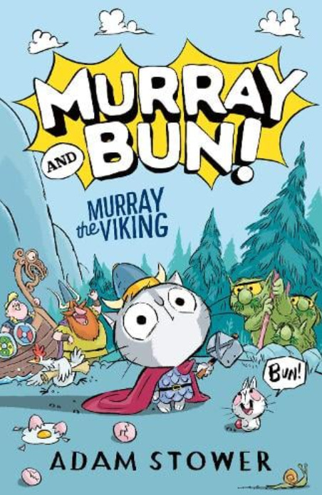 | Murray the Viking – Adam Stower  Murray the Viking by Adam Stower | Waterstones
Fiction | 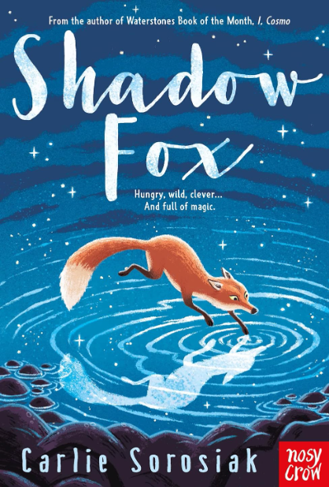 | Shadow Fox - Carlie Sorosiak  Shadow Fox : Carlie Sorosiak: Amazon.co.uk: Books
Non Fiction | 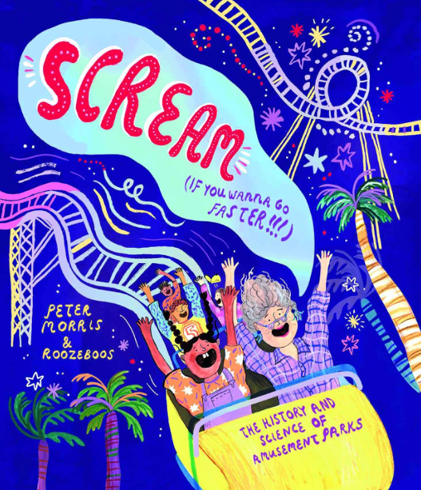 | Scream If You Wanna Go Faster – Peter Morris  Scream If You Wanna Go Faster!: The History and Science of Amusement Parks : Morris, Peter, Roozeboos: Amazon.co.uk: Books
Poetry | 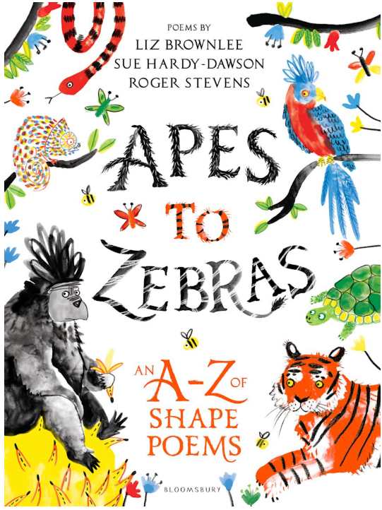 | Apes to Zebras: An A-Z of Shape Poems - Roger Stevens, Liz Brownlee & Sue Hardy-Dawson  Apes to Zebras: An A-Z of Shape Poems: Artistically arranged poetry to bring both words and animals to life: Roger Stevens: Bloomsbury Education - Bloomsbury
Graphic Novel | 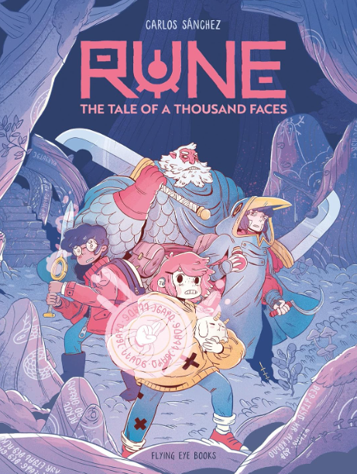 | Rune: The Tale of a Thousand Faces - Carlos Sánchez  Amazon.co.uk : rue the tale of a thousand faces
Fiction | 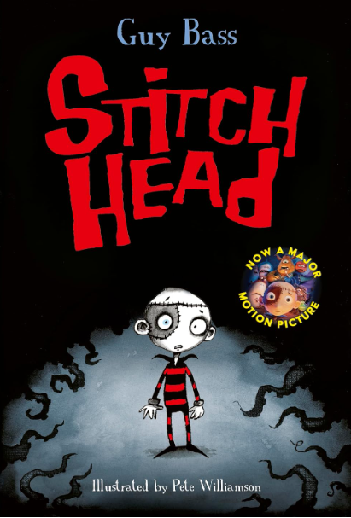 | Stitch Head - Guy Bass & Pete Williamson  Stitch Head: 1 : Bass, Guy, Williamson, Pete: Amazon.co.uk: Books
Non Fiction | 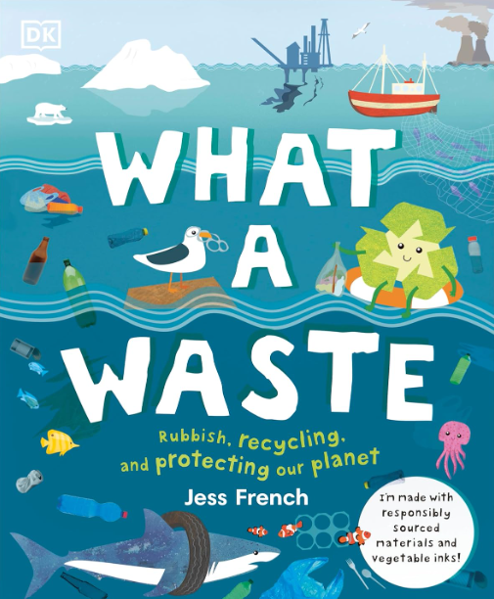 | What a Waste - Jess French  What A Waste: Rubbish, Recycling, and Protecting our Planet (Protect the Planet) : French, Jess: Amazon.co.uk: Books
Fiction | 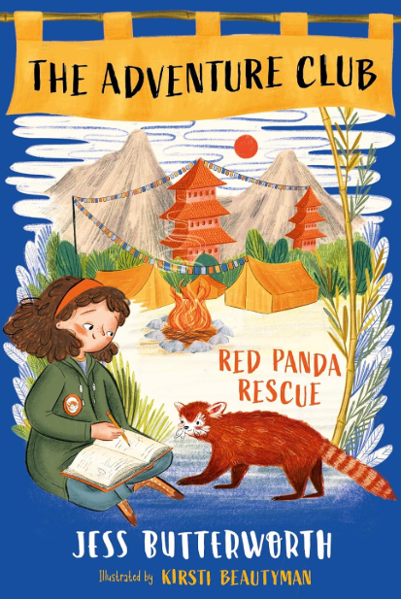 | Red Panda Rescue - Jess Butterworth  Red Panda Rescue: Book 1 (The Adventure Club): Amazon.co.uk: Butterworth, Jess, Beautyman, Kirsti: 9781510107960: Books
Fiction | 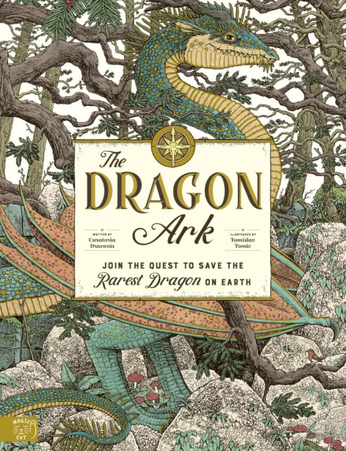 | The Dragon Ark - Curatoria Draconis  The Dragon Ark: Join the quest to save the rarest dragon on Earth: 1: Amazon.co.uk: Draconis, Curatoria, Tomic, Tomislav: 9781916180581: Books
Non Fiction | 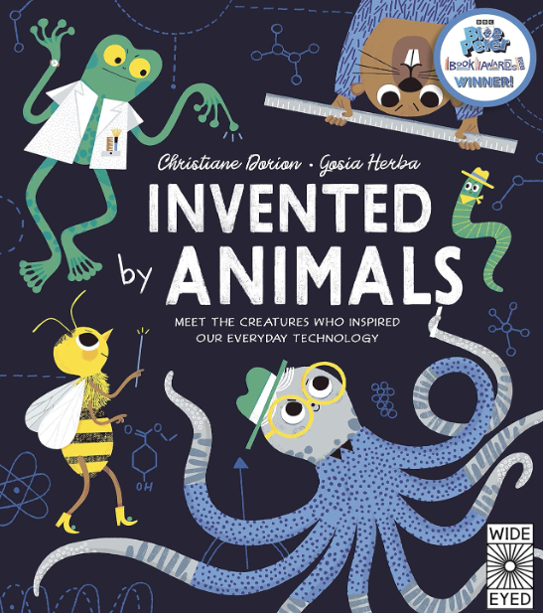 | Invented by Animals - Christian Dorion & Gosia Herba  Invented by Animals: Meet the creatures who inspired our everyday technology (Designed by Nature) : Dorion, Christiane, Herba, Gosia: Amazon.co.uk: Books
Poetry | 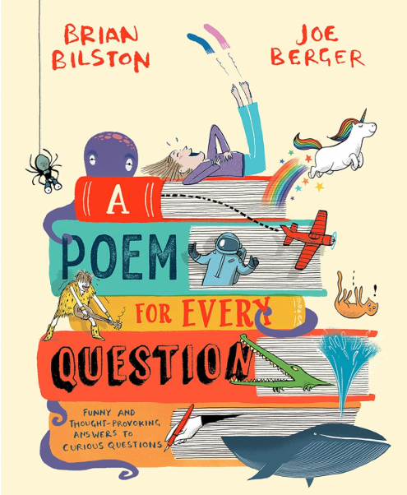 | A Poem for Every Question - Brian Bilston  A Poem for Every Question: A new illustrated funny and fact-filled non-fiction children’s poetry book for 2026, great for kids aged 6+ : Bilston, Brian, Berger, Joe: Amazon.co.uk: Books
Fiction | 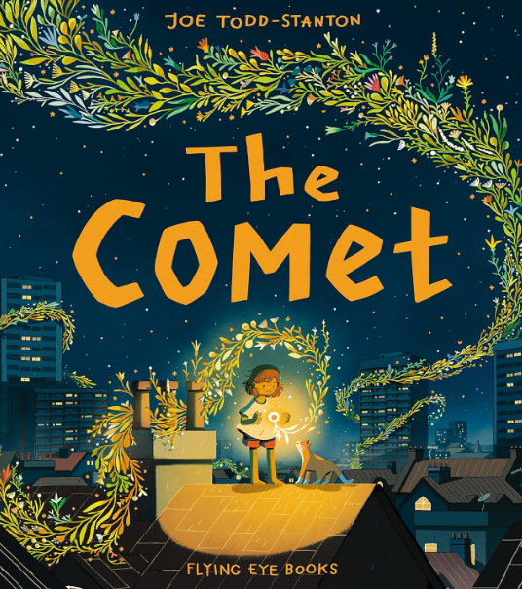 | The Comet – Joe Todd-Stanton  The Comet: Joe Todd-Stanton: Amazon.co.uk: Joe Todd-Stanton: 9781838740658: Books

