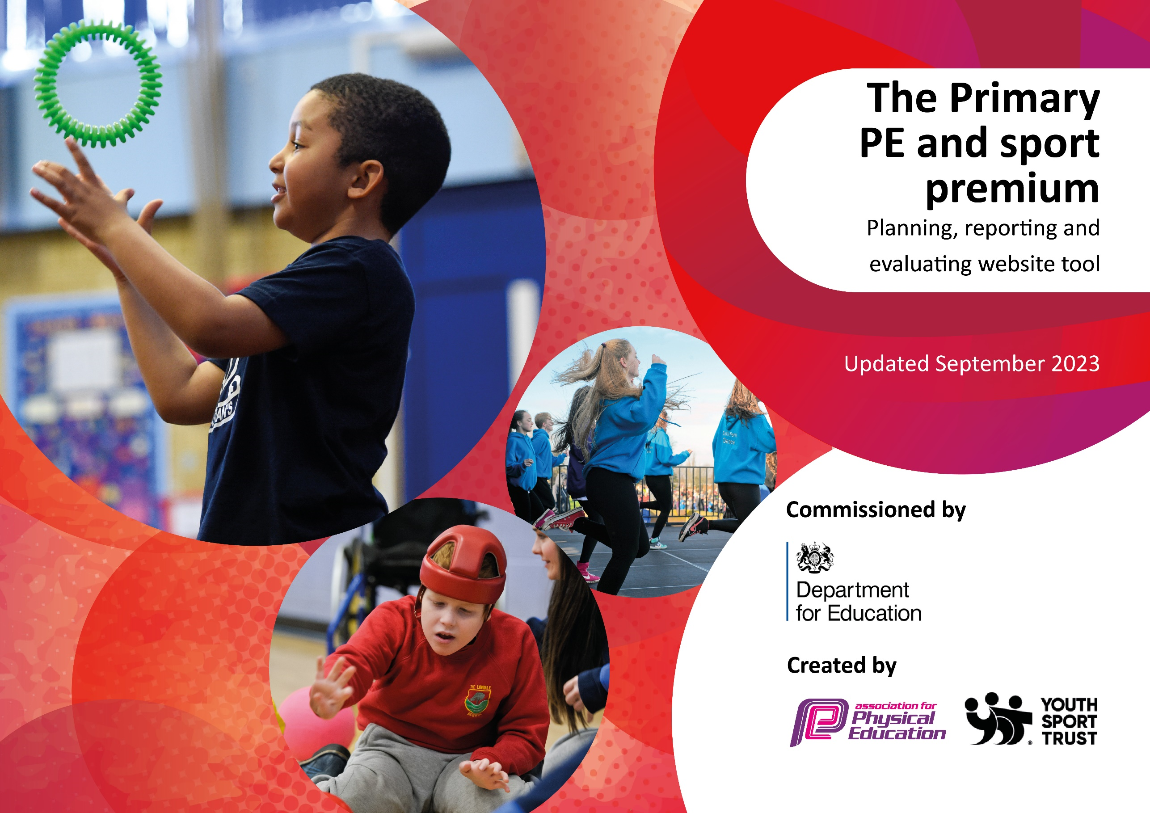


This template can be used for multiple purposes:
by:
- It enables schools to effectively plan their use of the Primary PE and sport premium
- It helps schools to meet the requirements (as set out in guidance) to publish information on their Primary PE and sport premium
- It will be an effective document to support Ofsted inspections enabling schools to evidence progress in Physical Education (PE) and evidence swimming attainment, which forms part of the PE National Curriculum. We would recommend schools consider
the Intent, Implementation and Impact of any spend, as examined within the Education Inspection Framework.

It is important that your grant is used effectively and based on school need.

Schools must use the funding to make additional and sustainable
improvements to the quality of the PE, School Sport and Physical Activity (PESSPA)
they offer. This means that you should use the Primary PE and sport premium to:

- Build capacity and capability within the school to ensure that improvements made now will benefit pupils joining the school in future years
- Develop or add to the PESSPA activities that your school already offers.

The Primary PE and sport premium should not be used to fund capital spend projects; the school’s core budget should fund these. Further detail on capital expenditure can be found in the updated Primary PE and sport premium guidance.

The Primary PE and sport premium guidance, outlines 5 key priorities that funding should be used towards. It is not

necessary that spending has to meet all the key priorities, you should select the priorities that you aim to use any funding towards.

Although completing this template is not a requirement for schools, schools are required to publish details of how they spend this funding. Schools must also outline what the impact this funding has had on pupils’ PE and sport participation and attainment and how any spending will be sustainable in the future. All funding must be spent by 31st July 2026.

The Department for Education has worked closely with the Association for Physical Education (afPE) and the Youth Sport Trust (YST) to develop this template and encourages schools to use it. This template is an effective way of meeting the reporting requirements of the Primary PE and sport premium.
Review of last year’s spend and key achievements (2024/2025)

We recommend you start by reflecting on the impact of current provision and reviewing your previous spend.

Activity/Action | Impact | Comments
- Incorporate active 30 minutes into our daily diet  - High quality sports coaching and staff CPD  - Planning for coverage and progression is in place  - Nurture groups happened  - Mental health and wellbeing had support through the sports funding with yoga, quidditch and inclusion week.  - Equipment was high quality, and was used to support physical wellbeing  - To develop outdoor learning through the orienteering course and the use of forest schools. | Children were very active last year, there was an increase in active minutes. With the implementation of the orienteering course lots of outdoor learning was also taking place  All teaching staff took part in the PE coaches lessons developing their knowledge of PE teaching and learning  Yoga, and nurture had a positive impact on mental health and wellbeing. Children were more regulated during these sessions.  Children are more confident with their Physical ability and the wide range of sporting skills that they are developing | Where possible through go noodle, mindful breathing, active learning, the onsite subject wide orienteering course, residential and playground games with sports leaders. The children have achieved target  High quality coaching has been happening all year, this has been quality assured by SLT and the provision has improved for the early years.  Planning is in place and shared on the teams  Nurture groups have happened as well as the Quidditch, yoga, multiskills and other sporting activities  Outdoor learning has taken place throughout the year across many different subjects and have enhanced the learning experience for all. Forest schools has been taught throughout all age ranges.

Key priorities and Planning
This planning template will allow schools to accurately plan their spending.

Action – what are you planning to do | Who does this action impact? | Key indicator to meet | Impacts and how sustainability will be achieved? | Cost linked to the action

 |  |  | Total | £17,690  £17,690 allocated from the sports premium topped up by general budget

Key achievements 2023-2024
This template will be completed at the end of the academic year and will showcase the key achievements schools have made with their Primary PE and sport premium spending.

Activity/Action | Impact | Comments
Rich after school club diet for the children  Quidditch took place and was enjoyed by all the children  Resources have been audited and developed further- children playing are active and are using the equipment to develop their catching and throwing skills.  Mini medics was a great success again  Sports leaders were trained and started to develop games at play and lunch. They also helped to organise and run sports day  Competitive sports were attended by different groups of children  Disability sports week was a great success  Catch up swimming was sourced and paid for through a grant, 45% of the children reached the 25m | 120 children attended, multiskilled, yoga,  Quidditch developed competitive skills and also gave some children a different outlet to football.  Resources bought and used well developing different skills in children and helping them develop their play  Sports leaders have developed their leadership skills, working with younger children and helping them to develop too.  Competitive events were attended with varied success  Disability sports gave the children a real insight into this world and they loved the sports and could see how a disabled person with adaptations could access what everyone can access  Swimming is higher % because of the catch up intensive course

Swimming Data
Meeting National Curriculum requirements for swimming and water safety.
Priority should always be given to ensuring that pupils can perform safe self-rescue even if they do not fully meet the first two requirements of the National Curriculum programme of study

Question | Stats: | Further context  Relative to local challenges
What percentage of your current Year 6 cohort can swim competently, confidently and proficiently over a distance of at least 25 metres? | 70% | This was quite a good data set for us as they were a sporty cohort, quite a few parents in this class took their children for private swimming lessons. This an increase for us because of the catch
What percentage of your current Year 6 cohort can use a range of strokes effectively [for example, front crawl, backstroke, and breaststroke]? | 70% | Our children do struggle with confident breaststroke and enjoy backstroke more. Their front crawl doesn’t always have the correct breathing and is more like a doggy paddle hybrid

What percentage of your current Year 6 cohort are able to perform safe self-rescue in different water-based situations? | 70% | Use this text box to give further context behind the percentage.
If your schools swimming data is below national expectation, you can choose to use the Primary PE and sport premium to provide additional top-up sessions for those pupils that did not meet National Curriculum  requirements after the completion of core lessons. Have you done this? | Yes/No | We accessed send swimming through SAP
Have you provided CPD to improve the knowledge and confidence of staff to be able to teach swimming and water safety? | Yes/No | Water safety is covered as a session by school swimming. The swimming service provide all qualified swimming teachers therefore CPD is not necessary

Signed off by:

Head Teacher: | Jo Yardley
Subject Leader or the individual responsible for the Primary PE and sport premium: | Matt Debic
Governor: | Kevin Poxon
Date: | 09.09.2026

