Year 2, Unit 11: Position and Direction

What is this learning about?
In this topic, children explore position, direction and movement. They learn to describe where objects are and how they move using positional language and turns.
This helps develop spatial awareness, logical thinking, and early map-reading skills.

By the end of this unit, your child should be able to:

- Use mathematical vocabulary to describe position, direction and movement
- Understand and use the words: left, right, forwards, backwards
- Describe turns using quarter, half, three-quarter and full turns
- Use clockwise and anticlockwise to describe direction of turns
- Recognise and create simple patterns and sequences involving position and direction

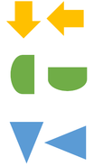 | 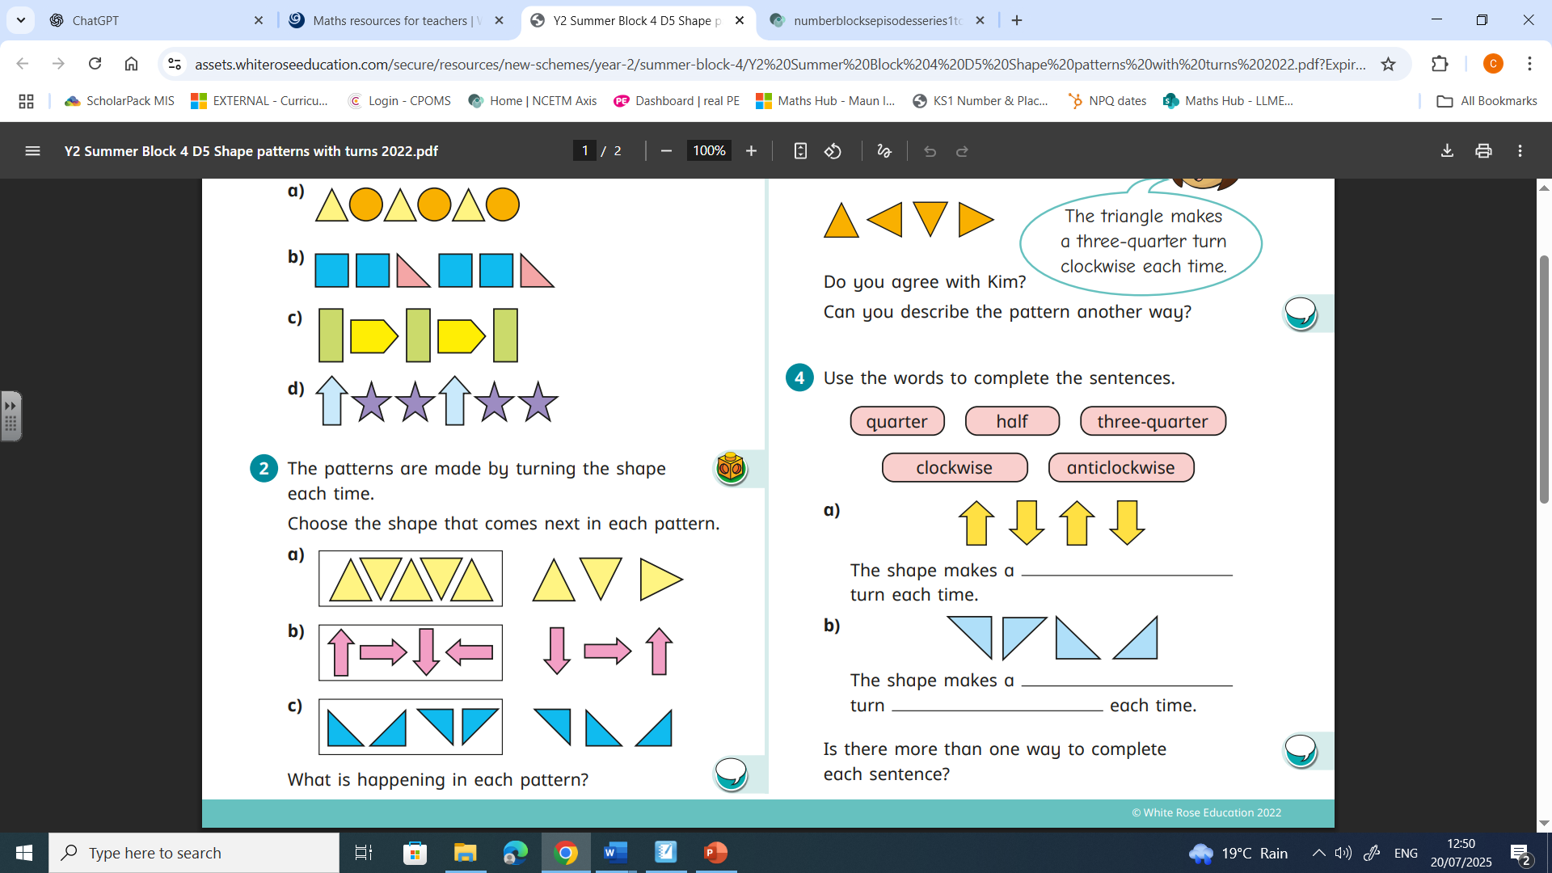 | 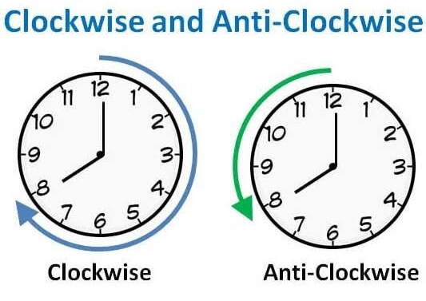
Turning objects  (Children will practise turning objects clockwise and anticlockwise.) | Completing patterns with turns  (Children will complete patterns by thinking about the way the objects are turning.) | Clocks  (Children will use clocks to learn which way is clockwise and which is anticlockwise.)
How we will teach this learning:

How can I support at home?
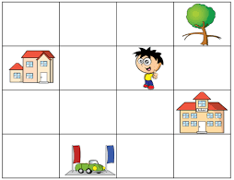
- Treasure Hunt: Give your child directions like “Take two steps forward, turn clockwise a quarter turn, then go left…” and hide a small prize at the end.
- Simon Says – Direction Edition: Use turns and positions in the game (e.g. “Simon says turn half turn clockwise”).
- Toy Map Navigation: Place toys on a grid or mat and give instructions to move them (e.g. “Move the car 2 spaces forward and turn right”).
- Cooking with Directions: Talk about which way to turn lids (clockwise/anticlockwise) or move around the kitchen following directions.
- Dance Turns: Create a simple dance using full, half, and quarter turns to music.
- Watch this numberblocks episode with your child:
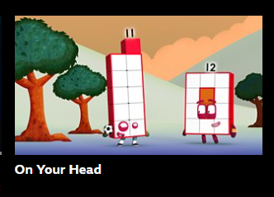
BBC iplayer: Series 4

