Year 2, Unit 10: Statistics

What is this learning about?
In this unit, your child will learn how to collect, organise, and understand data. They’ll begin working with simple charts, pictograms, and tally charts. This helps them understand how information can be used to answer questions and spot patterns (We will practise this skill in our science learning too!)

By the end of this unit, your child should be able to:
- Sort and organise objects into categories
- Draw and understand pictograms (where each symbol may represent one or more items)
- Read and create block diagrams (bar charts)
- Create and interpret tally charts
- Compare data (e.g. "Which is the most popular?", "How many more...?", "How many fewer...?")

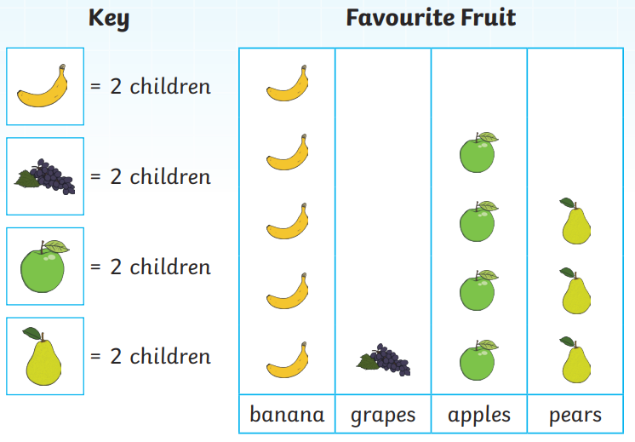 | 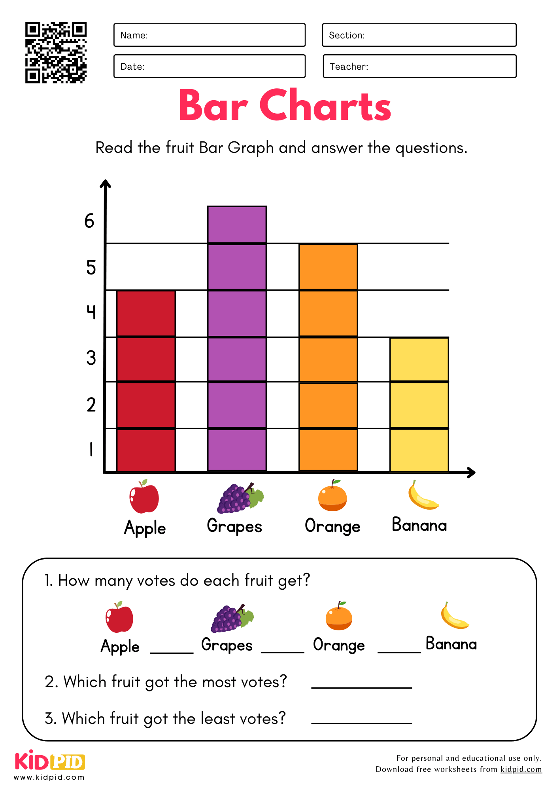 | 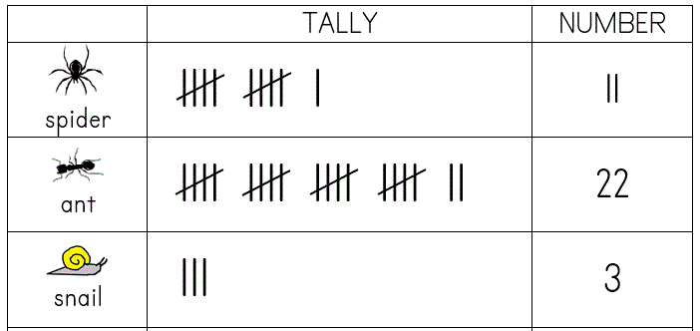
Pictograms  (Pictograms are tables with pictures on them to help the children read them.) | Bar charts  (Children will move onto bar charts after securing pictograms. Bar charts have coloured bars to represent numbers.) | Tally charts  (Children need to know that for the fifth tally mark they ‘shut the gate’ they can then quickly count in 5s.)
What will we use to teach this?

How can I support at home?
- Home Surveys: Ask your child to collect data about something (e.g. favourite fruit in the family, pets people have, colours of cars outside). Create a tally chart and pictogram to show the results.
- Toy Sorting: Sort toys or objects by type, colour, or size. Create a simple bar chart or pictogram to show the results.
- Weather Chart: Keep a weekly record of weather (sunny, rainy, cloudy) and graph it together at the end of the week.
- Tally the TV: Count how many times different animals appear in a documentary or cartoon – then graph the results!

Read books such as:


