Year 2, Unit 9: Time

What is this learning about?
In this unit, your child will develop their understanding of time, learning to read clocks to the nearest 5 minutes and solve time-based problems. They’ll also build on skills learned in Year 1 by reading with analogue and digital clocks.

By the end of this unit, your child should be able to:
- Know which hand is the hour hand and which is the minute
- Tell and write the time to the hour and half past
- Tell and write the time to the quarter past and quarter to the hour
- Use terms like o’clock, half past, quarter past, quarter to
- Know there are 60 minutes in an hour
- Know there are 24 hours in a day.
- Sequence events in chronological order using language such as before, after, next, earlier, later
- Read time on analogue and digital clocks
- Solve practical problems involving time (e.g. how long something takes)

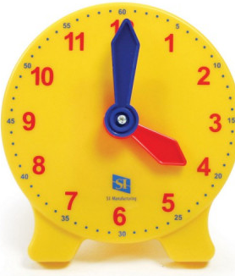 | 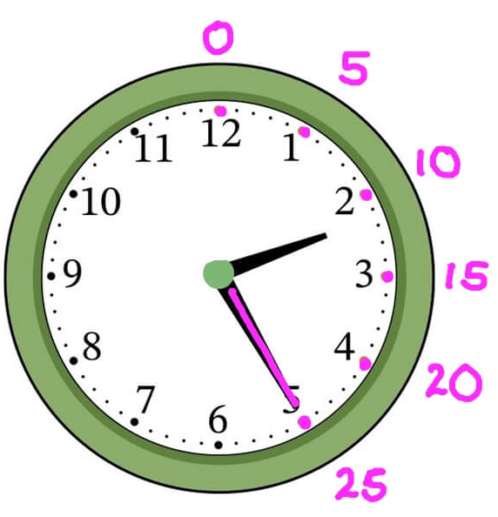 | 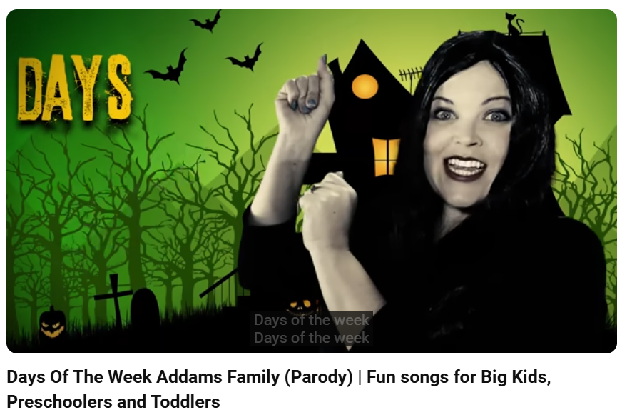 | 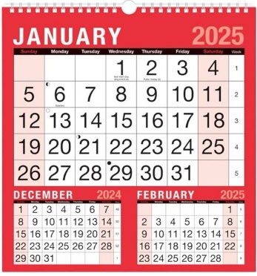
Clocks  (Children will practise making the time on clocks.) | Counting in 5s around the clock  (Children will count in 5s around the clock to learn there are 60 minutes in an hour.) | Songs  (Children will sing songs to help them learn days of the week) | Calendars  (Children will look at calendars to learn the days of the week and months of the year.)
What will we use to teach this?

How can I support at home?
- Watch this number blocks episode to reinforce key language.
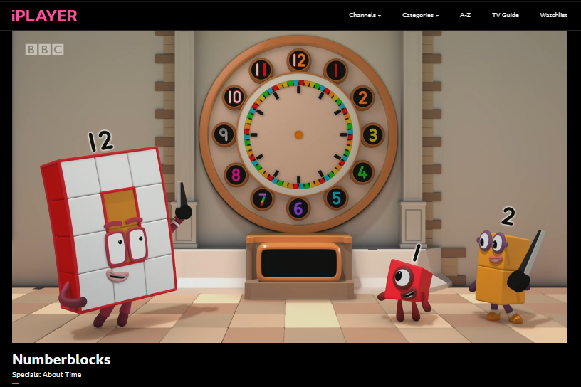
- Clock Matching Game: Create or print clock faces showing times (e.g. quarter to 3) and match them with digital times.
- What’s the Time, Mr Wolf?
- Time My Task: Use a timer or stopwatch for fun challenges — e.g. “How long does it take you to brush your teeth?” Then compare.
- Daily Routine Talk: Discuss your child’s daily routine using time words: “What time do you eat breakfast?” or “What do you do at quarter past 8?”
- Sing songs – like the Days of the Week or Months of the Year song
Read books such as:


