Year 2, Unit 8: Fractions

What is this learning about?
In this unit, your child will begin to explore fractions as equal parts of a whole. They’ll learn about halves, quarters and thirds, and understand how to identify, find and use these fractions in different contexts such as shapes, quantities, and numbers.
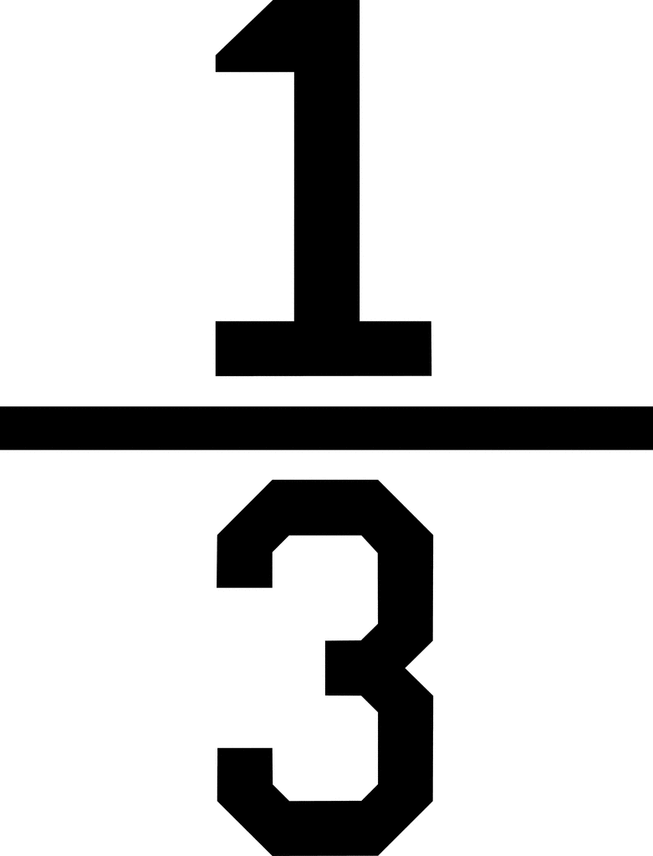
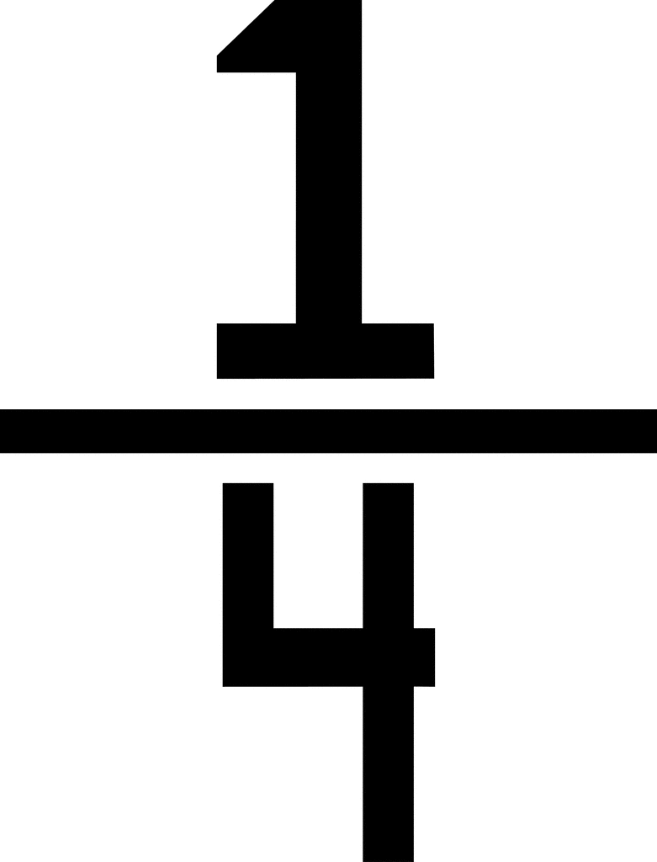
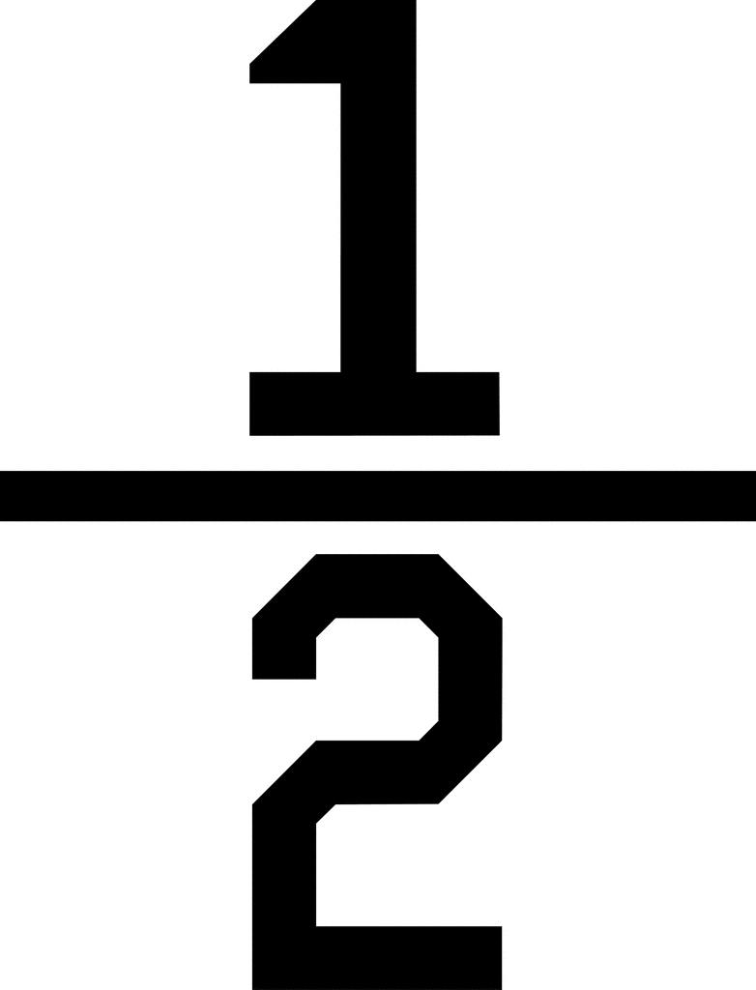
Children will begin with practical learning and will link this to fractions written as:

What will your child learn:
- Recognise and find ½ (one half), ⅓ (one third), ¼ (one quarter) and ¾ (three quarters) of shapes, objects, and quantities
- Know a halving is the opposite of doubling
- Understand that fractions are equal parts of a whole
- Recognise that two halves make a whole, and four quarters make a whole
- Recognise and use the terms numerator and denominator
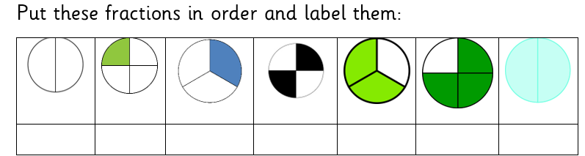
- Order fractions from smallest to biggest
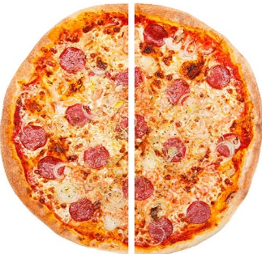 | 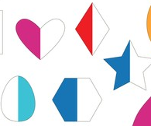 | 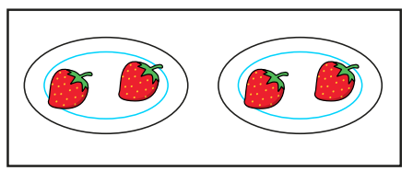 | 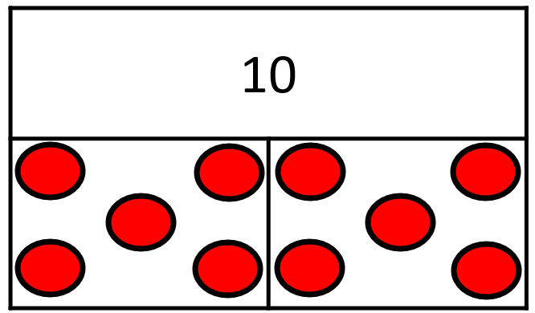
Everyday items  (Children will practise cutting and folding real objects into halves.) | Halving shapes  (Children will practise finding half of shapes.) | Sharing objects practically.  (Plates can be used for children to share objects equally.) | Bar models  (Bar models can be used for children to share objects equally.)
- Solve simple problems using fractions
How we will teach this learning:
How can I support at home?
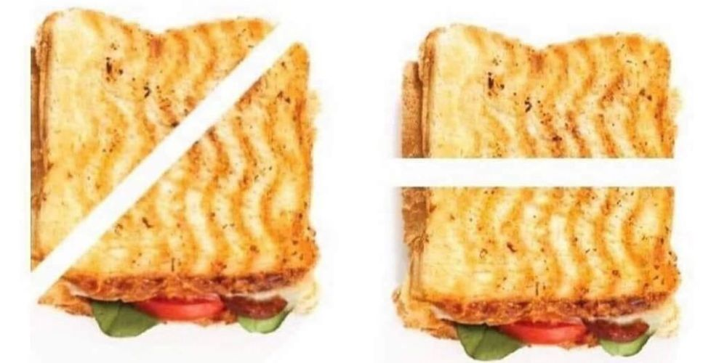
- Cut food into halves and quarters – “Shall we cut your sandwich in half?”
- Share toys or snacks fairly – “Let’s split these 8 grapes into 4 groups”
- Fold paper – into halves and quarters and compare the sizes
- Talk about parts and wholes – “You ate one quarter of your apple – how many parts make the whole?”
- Play ‘fair share’ games – “Can you share these 12 Lego bricks into 2 equal groups?”
- Bake Together: Use measuring cups or scales to introduce real-life fractions (½ cup of flour, ¼ tsp of salt, etc.).

Read books such as:
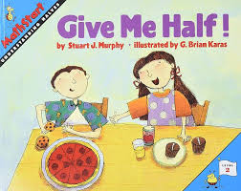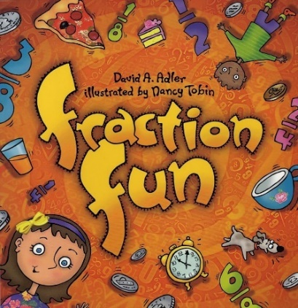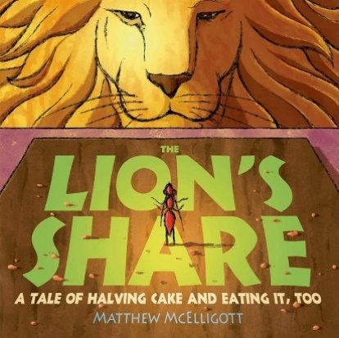

These number blocks episodes may help:
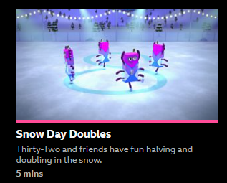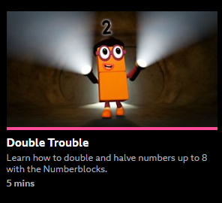
Series 5 Series 2

