Year 2, Units 6 & 7: Measurement (Length, Height, Mass, Volume and temperature)

What is this learning about?
In these measurement units, your child will explore different ways of measuring and comparing objects and quantities in the world around them. They will work with units such as centimetres, metres, grams, kilograms, millilitres, litres, and degrees Celsius to measure, estimate, and solve practical problems.

By the end of these units, your child should be able to:
Length and Height:
- Compare and order lengths and heights using vocabulary like longer, shorter
- Measure length/height in centimetres (cm) using a ruler
- Solve problems involving length and height using addition and subtraction
Mass (Weight):
- Compare and describe mass using vocabulary like heavier, lighter
- Measure mass using grams (g) and kilograms (kg)
- Solve simple problems by adding and subtracting masses
Capacity and Volume:
- Compare and describe capacity using full, empty, more than, less than, half full
- Measure capacity in millilitres (ml) and litres (l)
- Solve problems involving volume and capacity
Temperature:
- Read temperatures on a thermometer
- Understand and describe temperature in degrees Celsius (°C)
- Solve simple comparison problems (e.g. which day was hotter?)
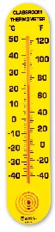 | 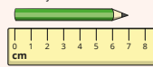 | 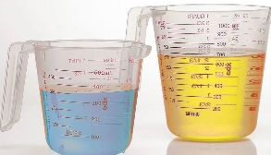 | 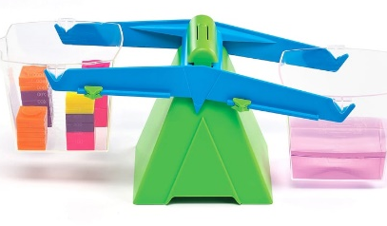 | 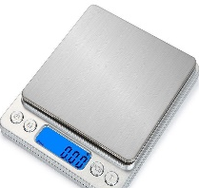
Thermometers  (Children will read temperatures on a thermometer.) | Rulers  (We will then move onto rulers so children can measure things in centimetres.) | Measuring jugs  (Children will practise reading the scales on the side of measuring jugs.) | Balancing scales  (Children will compare the mass of objects using balancing scales.) | Digital scales  (Children will measure the mass of objects in grams and kilograms.)

What will we use to teach this?

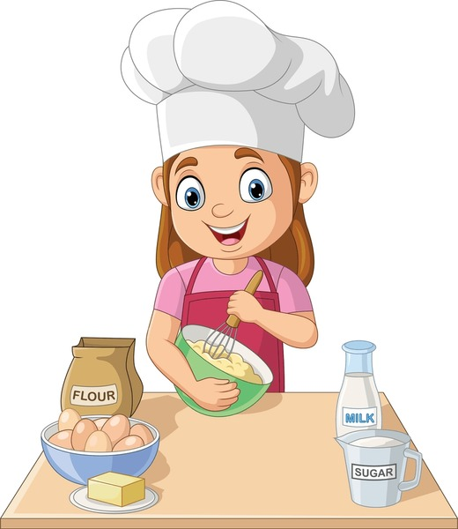
How can I support at home?
- Length Measuring Hunt: Use a ruler or tape measure to measure items around the house in cm/m. Record the results and order from shortest to longest.
- Weigh Your Snacks: Use kitchen scales to weigh fruit, cereal, or snacks in grams. Compare two items to see which is heavier.
- Water Play: Fill and pour using jugs or cups to estimate and measure capacity in ml/l. Try mixing "potions" with set amounts.
- Weather Watch: Check the temperature each day and record it on a chart. Talk about changes over the week.
- Cooking Together: Follow recipes and measure ingredients in grams or ml – a great way to reinforce accurate measuring.
Read books about measurement:
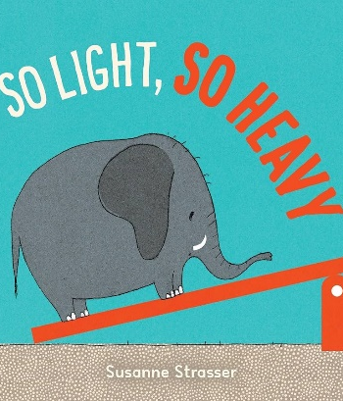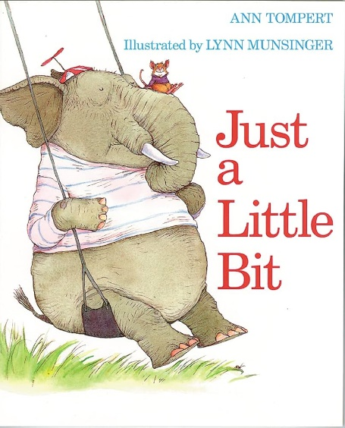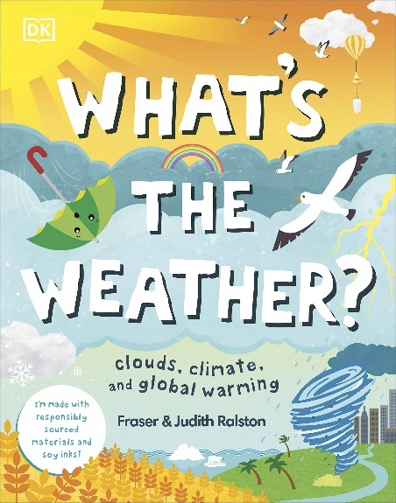

Number blocks episodes to help reinforce the correct language:
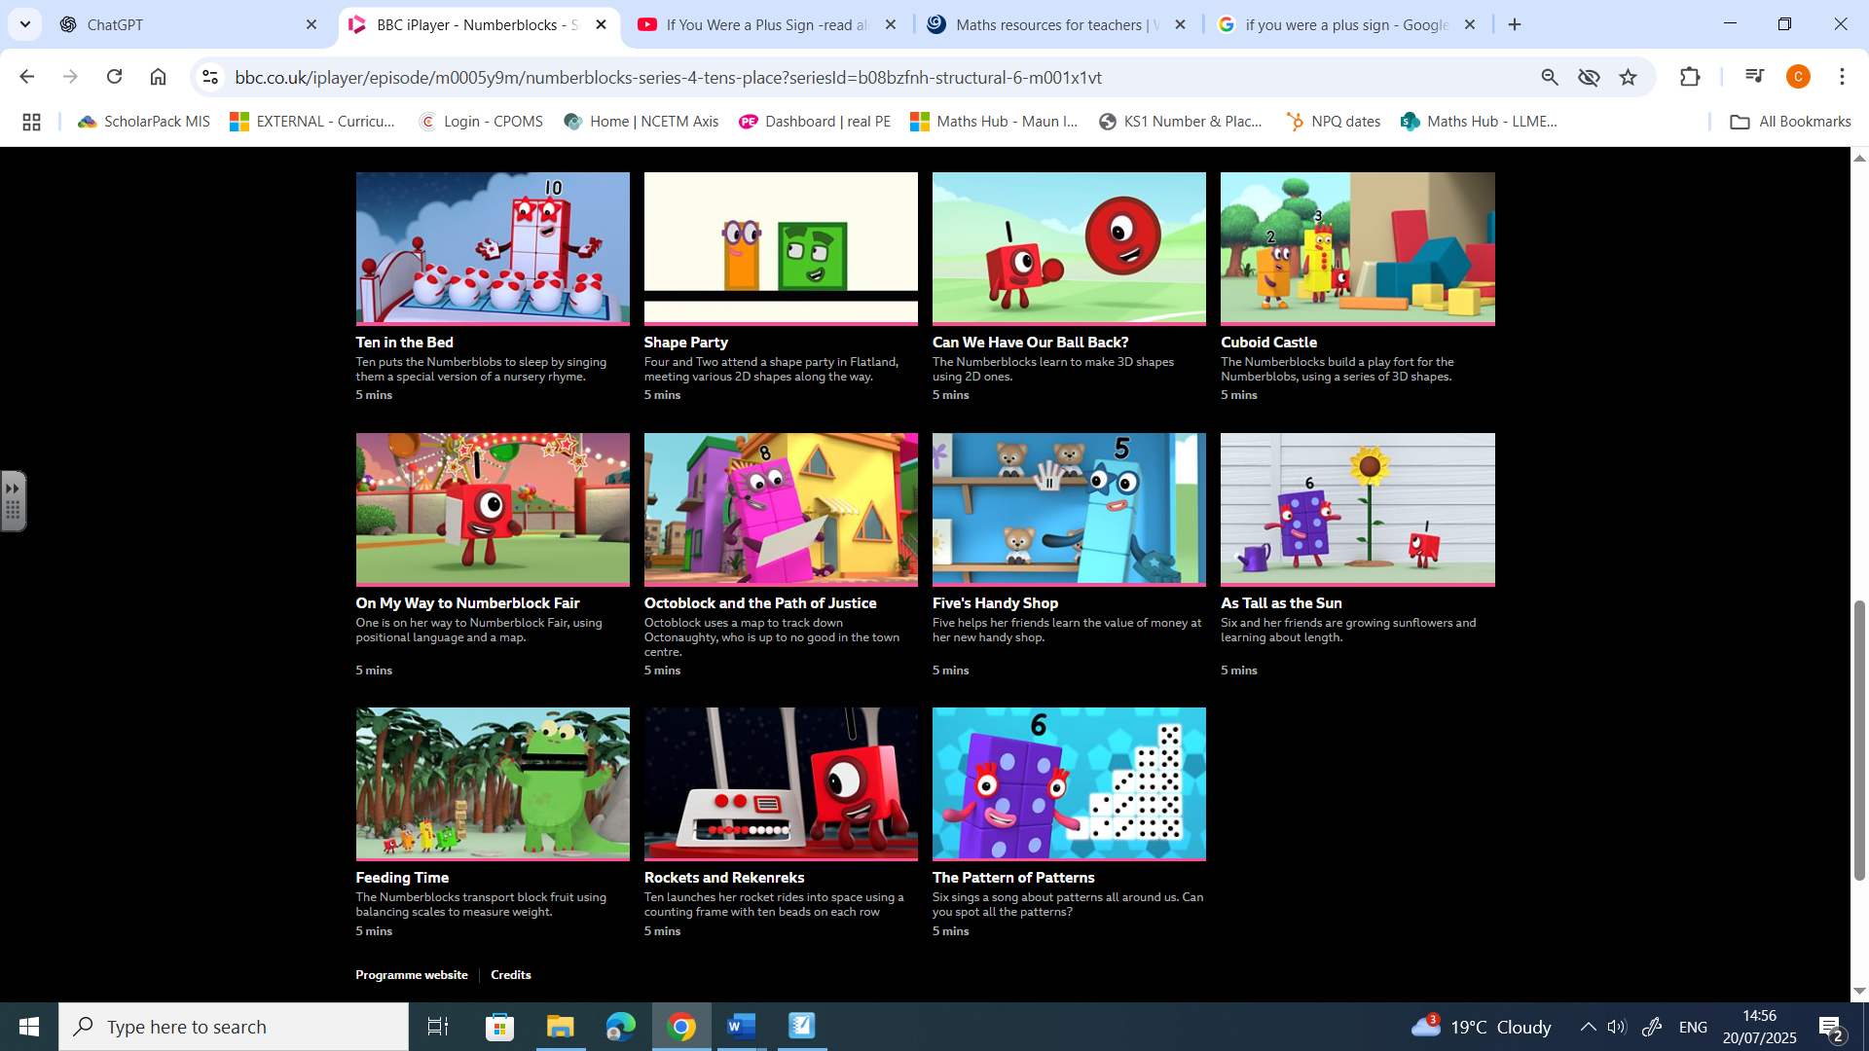
Series 6 Series 6

