Year 2, Unit 5: Multiplication and Division

What is this learning about?
In this unit, your child will learn how multiplication and division are related. They’ll begin by making equal groups and progress to using multiplication and division symbols. Children learn this practically to build a strong understanding of how to multiply and divide ready to become fluent at their times tables in Forest View.

By the end of this unit, your child should be able to:
- Recognise and make equal groups
- Add equal groups to find the total
- Understand multiplication as repeated addition
- Know the multiplication symbol (×) means ‘lots of’
- Solve division questions by sharing objects equally
- Know the division symbol (÷) means ‘shared equally by’
- Recognise the link between multiplication and division
- Recall and use multiplication and division facts for the 2, 5 and 10 times tables
- Solve one-step problems involving multiplication and division using objects and simple drawing

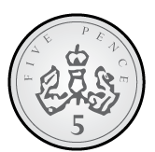  3 x 5 = 15 | 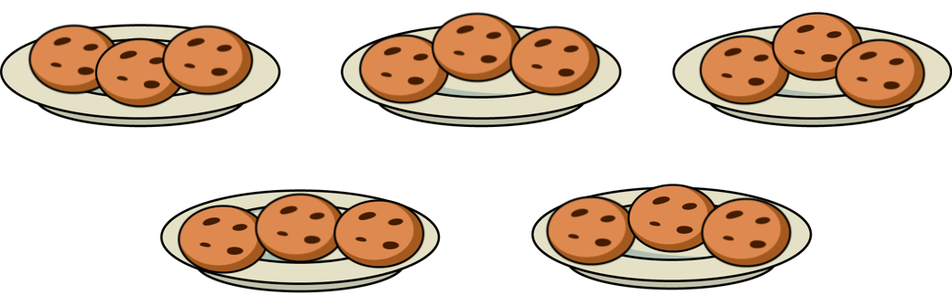  15 ÷ 5 = 3 | 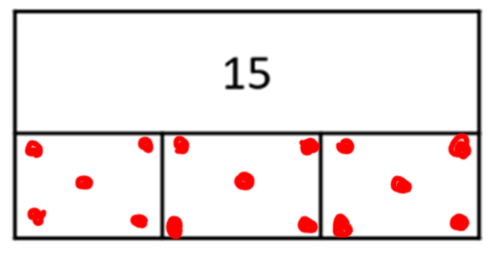 | 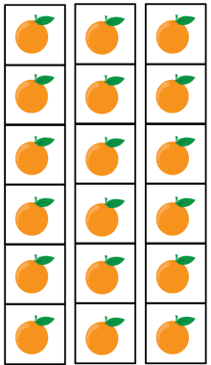  6 x 3 = 18 | 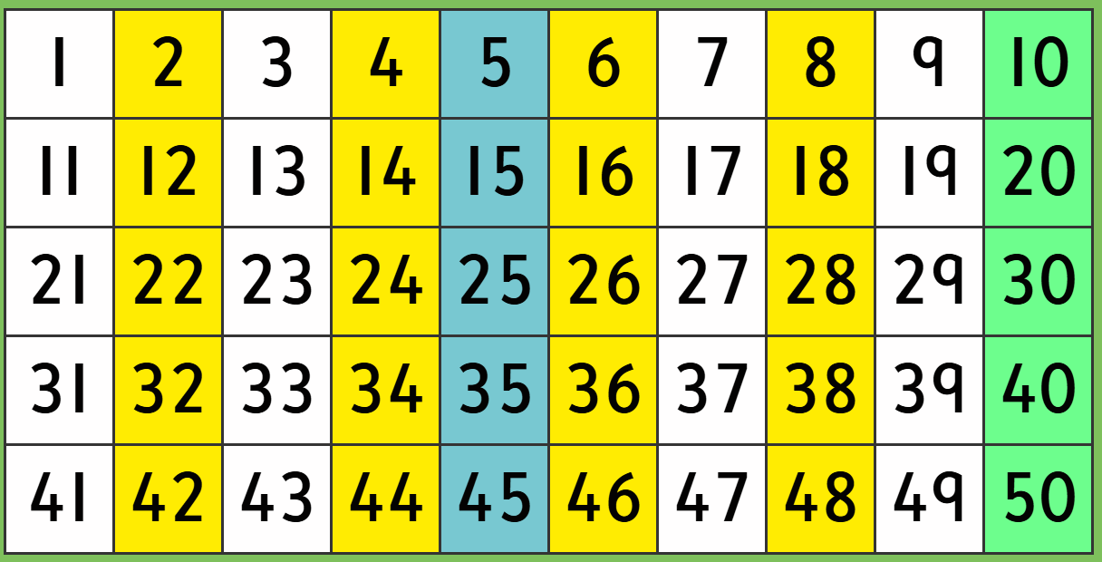
Everyday items  (Children will practise counting multiples of coins or notes.) | Sharing plates  (Children can share objects onto plates and check their groups are equal.) | Bar models  (Children draw counters to share the whole into equal parts.) | Arrays  (Pictures organised into rows and columns to show multiplication as repeated addition.) | Hundred squares  (Children will colour hundred squares in when counting in multiples to help them notice patterns.)
What will we use to teach this:

How can I support at home?
- Equal Grouping with Snacks or Toys: Ask, “Can you make 3 equal groups of 4 grapes?” or “Share 12 blocks between 4 people. How many each?”
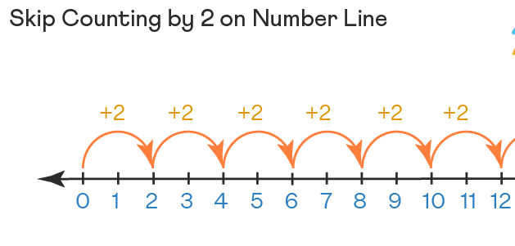
- Skip Count Together: Practise counting in 2s, 5s, and 10s while walking, hopping, or using a number line.
- Mini Shops: Use play money and price tags in 2s, 5s, and 10s to practise real-world multiplication.
- Practise sayng doubles together
Read books such as:
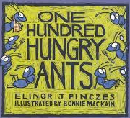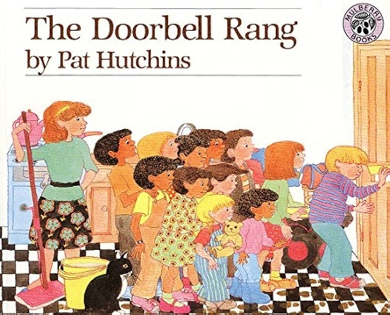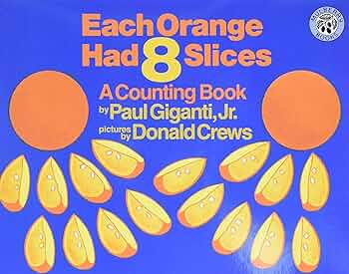

These numberblocks episodes may help:
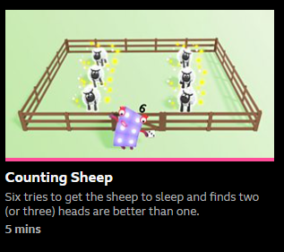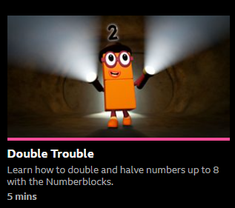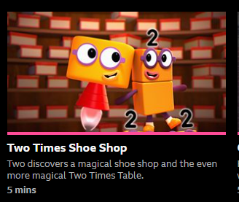
Series 2 Series 2 Series 5


