Year 2, Units 4: Money

What is this learning about?
In this unit, your child will learn to recognise coins and notes, understand their values. They will make amounts and solve simple problems like finding change. This is a great unit to connect maths to real life, and it’s one you can easily support at home!
Children are not expected to work with decimal notation (e.g. £0.20) but they will be introduced to the idea that 100p = £1.

By the end of this unit, your child should be able to:
- Recognise and name coins and notes (£1, £2, 50p, 20p, 10p, 5p, 2p, 1p, £5, £10, £20)
- Understand the value of each coin and note
- Count money to find a total
- Make a given amount using different combinations of coins
- Compare amounts of money (more than/less than)
- Find the total of two or more items
- Find change from a given amount
- Solve simple money problems involving addition and subtraction
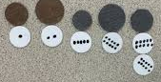 |  | 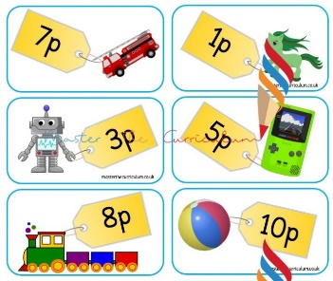 | 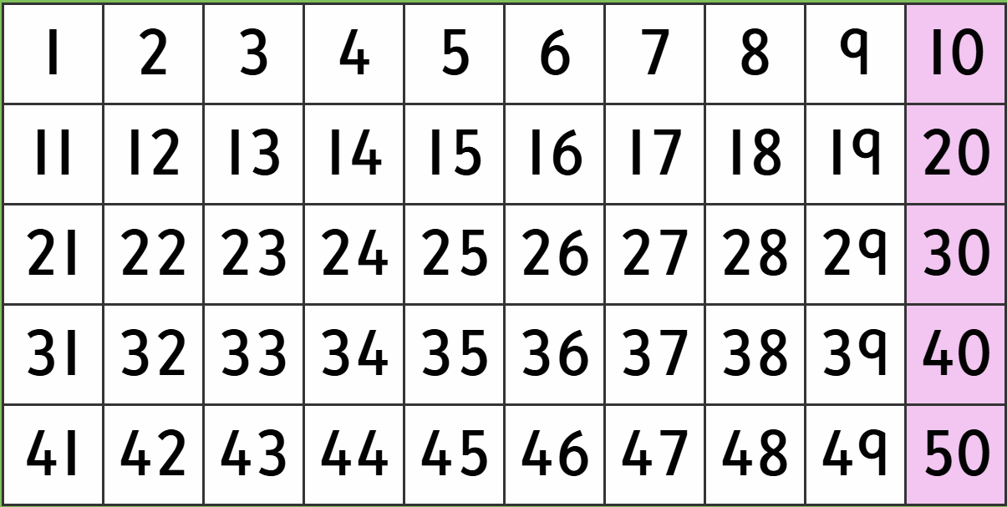  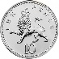
Pre- Money counters  (Children will use pre-money counters to learn that one object can be worth more than 1p regardless of shape or size.) | Money  (Children will use real money as they begin to sort and identify coins and notes.) | Price tags  (Children will be able to play ‘shops’ to consolidate their learning.) | Hundred squares  (Hundred squares can help children counting multiples)  e.g. five 10p coins = 50p
What will we use to teach this
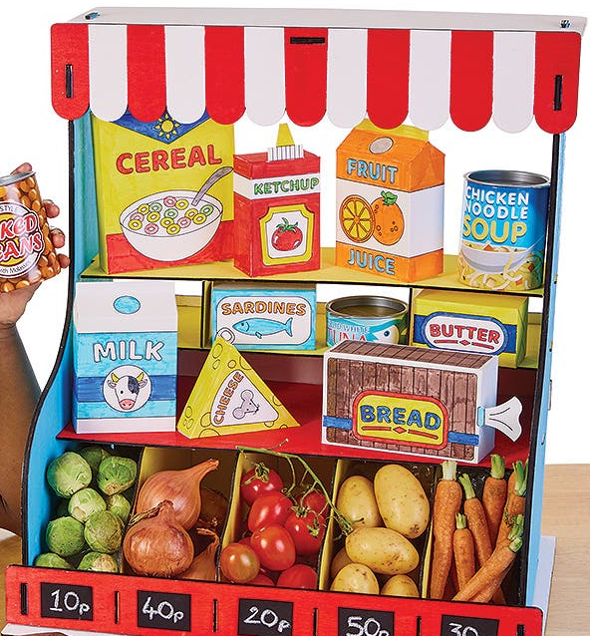
How can I support at home?
- Play Shops: Use real or pretend coins to buy items from a toy shop or kitchen. Label items with prices and take turns being the shopkeeper!
- Money Sorting: Ask your child to sort coins by size, colour, or value – and then practise adding them up.
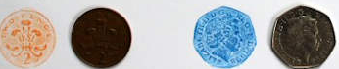
- Make a Total: Give your child an amount (e.g. 15p) and ask them to find all the different ways they can make it using coins.
- Real-Life Maths: Involve your child when paying for small items in a shop – let them help count the money or check the change.
- Coin Rubbings or Matching Games: Make rubbings of coins or draw pictures and match them to prices or values.

Read books such as: This numberblocks episode may help (Series 6)


