Year 2, Unit 3: Shape
What is this learning about?
In this unit, your child will explore 2D and 3D shapes, learning to recognise, name, describe, and sort them. They’ll look at the properties of shapes, such as the number of sides, edges, vertices (corners), and faces. This helps develop spatial awareness and the ability to reason and describe the world around them using mathematical language.

By the end of this unit, your child should be able to:
- Recognise and name 2D shapes (e.g. squares, circles, triangles, rectangles, pentagons, hexagons, octagons)
- Recognise and name 3D shapes (e.g. cubes, cuboids, spheres, cylinders, cones, pyramids)
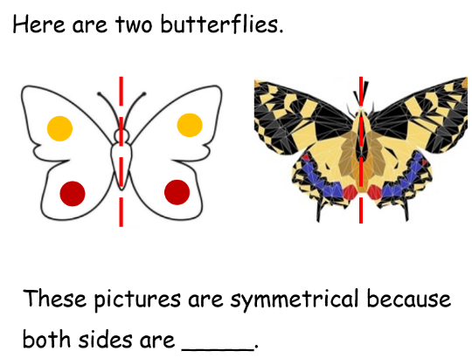
- Describe 2D shapes using sides and vertices
- Describe 3D shapes using faces, edges, and vertices
- Identify 2D shapes on the surface of 3D shapes (e.g. a circle on a cylinder)
- Compare and sort shapes based on their properties
- Understand symmetry in 2D shapes

What will we use to teach this?
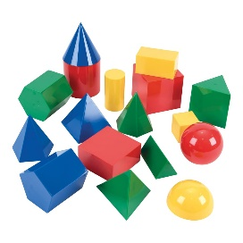 | 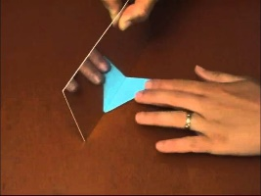 | 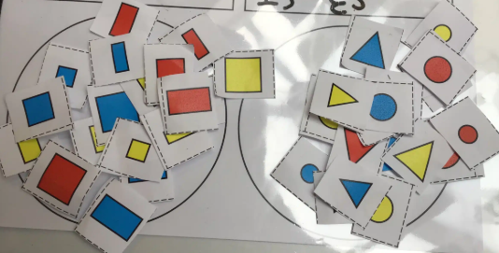 | 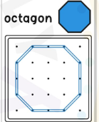
Shapes  (Children can notice the 2D shapes on the faces of 3D shape.) | Mirrors  (Children can use these to investigate lines of symmetry.) | Sorting hoops games  (Children might sort the shapes by number of sides – the above image has been sorted by 4 sides or not 4 sides.) | Geoboards  (Children can use these boards and elastic bands to make shapes.)

How can I support at home?
Watch these number blocks episodes with your child (Series 6 on iPlayer) 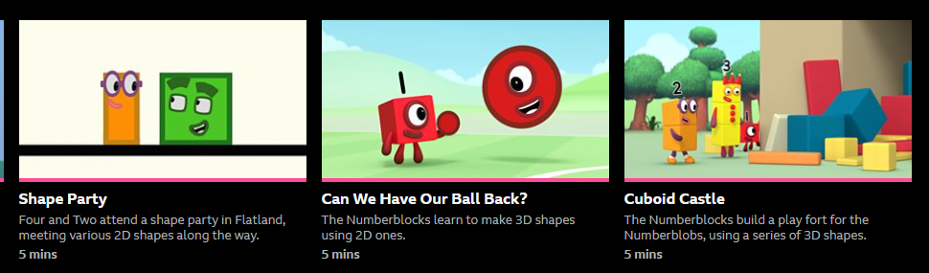
- Shape Hunt: Go on a 2D and 3D shape hunt around your home or outside.
- Junk Modelling: Use recycling materials to build models and talk about the shapes they’re made from.
- Look for 2D shapes in the faces of 3D shapes
- Shape Sorting: Cut out different shapes and sort them by number of sides, corners, or symmetry.
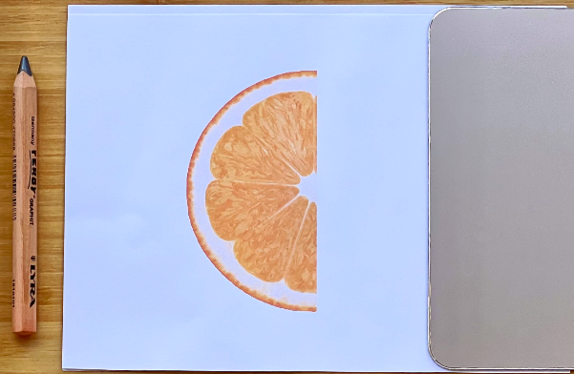
- Symmetry Art: Paint one side of a piece of folded paper and fold it again to make a symmetrical picture.
- Play “Guess My Shape”: Describe a shape without naming it (“I have 3 sides and 3 corners”) and have your child guess.
- Read books such as:


