Year 2, Unit 2: Addition and Subtraction

What is this learning about?
In this unit, your child will build on their knowledge of place value to develop strategies for adding and subtracting numbers up to 100. They'll learn to use mental methods, number facts, and visual representations to solve problems with confidence.
The focus is not only on getting the correct answer but understanding how and why the method works.

By the end of this unit, your child should be able to:
- Recall and use number bonds to 10 and 20 fluently
- Use related facts up to 100 (e.g. if 7 + 3 = 10, then 70 + 30 = 100)
- Add and subtract two two-digit numbers (e.g. 24 + 35)
- Draw tens and ones to help them solve their number sentence.
- Solve simple problems involving addition and subtraction, including missing number problems

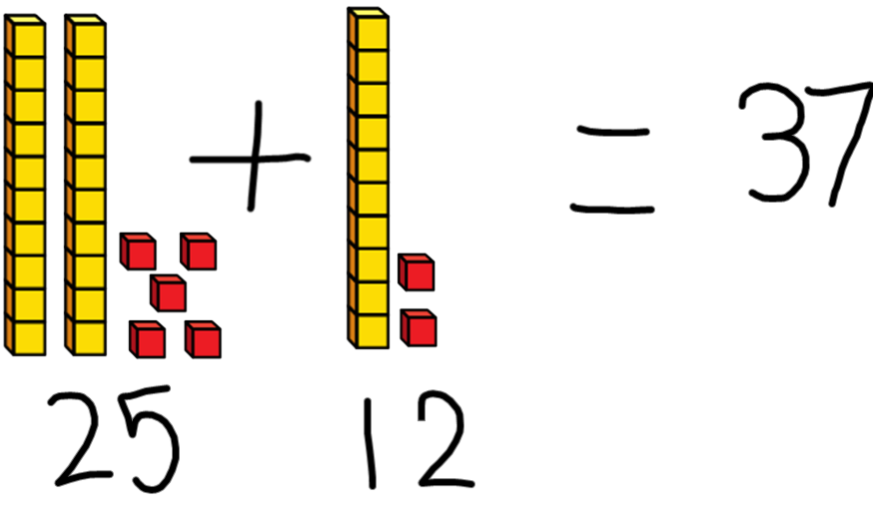 | 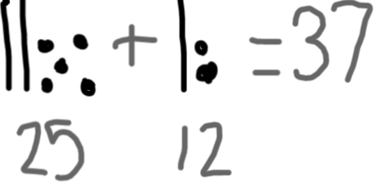 | 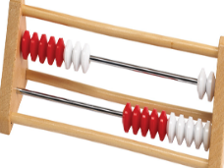 | Whole  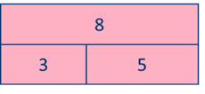  part part | 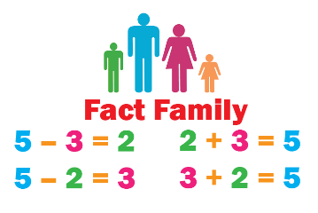
Base ten blocks  (Children will use the base ten blocks to add practically – noticing that 10 ‘ones’ are equal to 1 ‘ten’) | Drawing base ten blocks  (Children will then move onto accurately drawing their own base ten blocks to help them add and subtract.) | Rekenreks  (Children will notice the patterns when finding number bonds to ten – top row and twenty – both rows) | Bar models  (Children can split numbers into parts. They learn that:  part + part = whole  whole – part = part) | Fact families  (Children can see the relationship between adding and subtracting.)
What will we use to teach this?

How can I support at home?
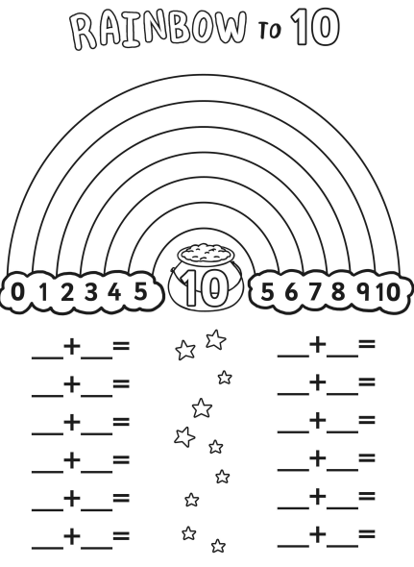
- Encourage children to order numbers to 100 Children can order numbers on a washing line
- Bond Builders: Use everyday objects (buttons, coins, pasta) to practise number bonds to 10 and 20.
- Roll and Add: Roll two dice and add the numbers.
- Shopkeeper Game: Set up a pretend shop using coins. Practise giving change using subtraction.
- Missing Number Puzzles: Write number sentences with missing parts (e.g. ___ + 7 = 20) and ask your child to solve them.
- Fact Family Triangles: Write three related numbers in a triangle (e.g. 4, 6, 10) and find all the addition and subtraction facts.

Number blocks episodes that will support this learning:
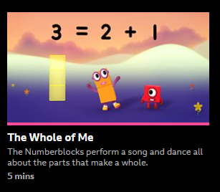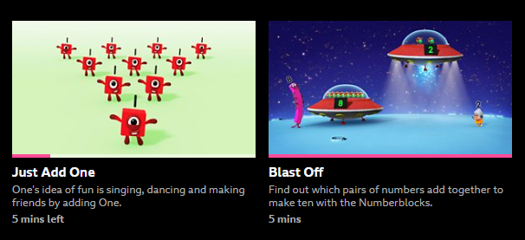
Series 1 Series 2 Series 2

