Year 2, Unit 1: Place value (within 100)

What is this learning about?
In this first unit of Year 2, your child will be building on their understanding of numbers from Year 1. They will explore numbers to 100, focusing on recognising, counting, comparing and representing numbers using different methods.
This unit is the most important as it lays the foundations of all the maths they will do this year.

By the end of this unit, your child will be able to:
- Count forwards and backwards from any number within 100
- Read and write numbers to 100 in numerals and words
- Know the place value a two-digit number (tens and ones)
- Partition numbers into tens and ones (e.g. 64 = 60 + 4)
- Accurately draw tens and ones
- Use a place value chart
- Compare and order numbers up to 100 using <, > and =
- Count in 2s and 5s
- Count on or back in 10s from any number
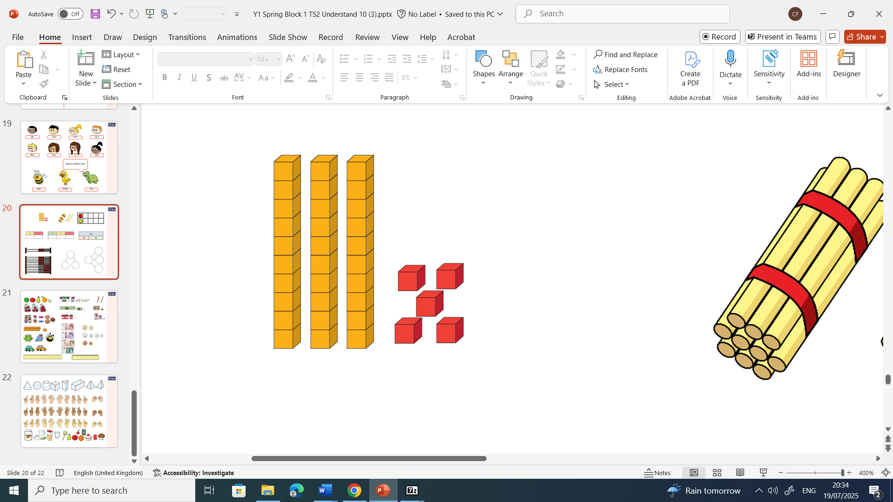  35 = 3 tens and 5 ones. | 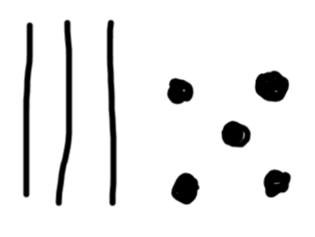  35 = 3 tens and 5 ones. | 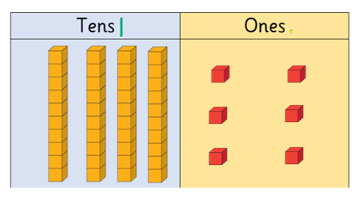 | 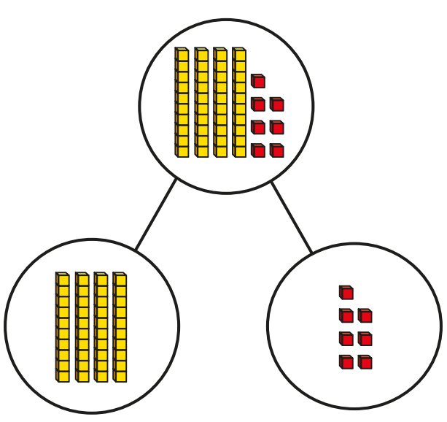 | 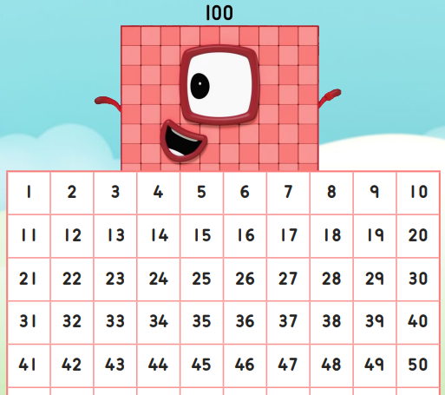
Base ten blocks  (Children can place 10 ‘ones’ net to 1 ‘ten’ and see they are equal.) | Drawing base ten  (Children will draw base ten to help them with calculations later on. They should draw 5 like a dice.) | Place value charts  (Children can organise numbers into tens and ones.) | Part whole models  Children can split numbers into tens and ones. | Hundred squares  (Hundred squares are great for recognising patterns.)

What will we use to teach this?

How can I support at home?
- Make number lines with some parts covered up and ask children to estimate what number would go there.
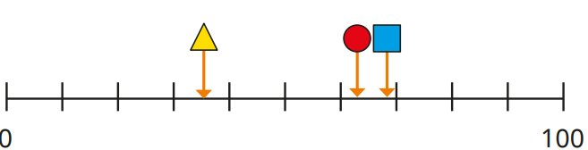
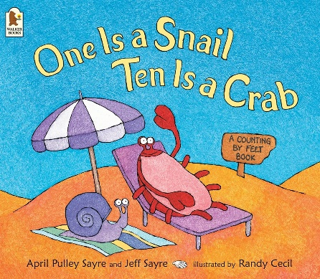
- Use Lego bricks, pasta or buttons to represent numbers. Group items in tens and ones, e.g. 43 = 4 groups of ten + 3 ones.
- Number Sorting: Write different two-digit numbers on cards. Ask your child to order them from smallest to largest and explain why.
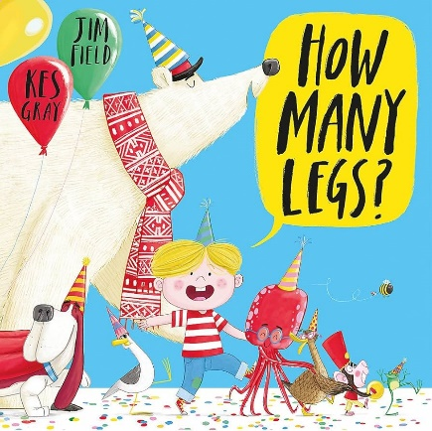
- Guess My Number: Think of a number between 1 and 100. Give clues like “It’s more than 30 but less than 50. It has 4 tens.”
- Counting Challenge: Practise counting in 2s, 5s and 10s while walking, skipping or clapping.
- Read books about maths and discuss them

