Y2 Core Book List 2026-2027 (12 Books)
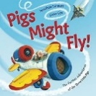
Fiction
- Pigs Might Fly by Jonathan Emmett
https://www.amazon.co.uk/dp/1987581199
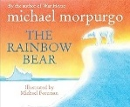
- The Rainbow Bear by Michael Morpurgo
https://www.amazon.co.uk/dp/0552546402
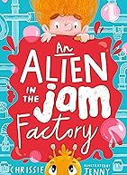
- An Alien in the Jam Factory by Chrissie Sains & Jenny Taylor
https://www.amazon.co.uk/dp/1406396125
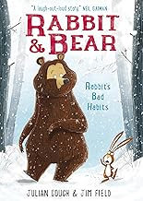
- Rabbit and Bear: Rabbit’s Bad Habits (Book 1) by Julian Gough
https://www.amazon.co.uk/dp/1444921681
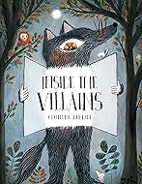
- Inside the Villains by Clotilde Perrin
https://www.amazon.co.uk/dp/1776571983
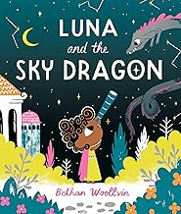
- Luna and the Sky Dragon by Bethan Woollvin
https://www.amazon.co.uk/dp/1529078342

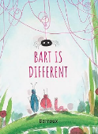
- Bart is Different by Barroux
https://www.amazon.co.uk/dp/1915659639

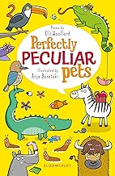
Poetry
- Perfectly Peculiar Pets by Elli Woollard & Anja Boretzki
https://www.amazon.co.uk/dp/1472958462

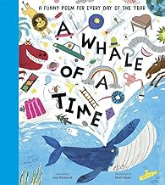
- A Whale of a Time: A Funny Poem for Everyday by Lou Peacock
https://www.amazon.co.uk/dp/1839942010

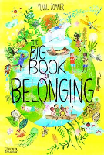
Non-Fiction
- The big book of Belonging by Yuval Zomer
https://www.amazon.co.uk/dp/0500652643
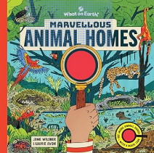
- Marvellous Animal Homes: A Magic Lens Book by Jane Wilsher
https://www.amazon.co.uk/dp/1804661473

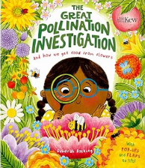
- The Great Pollination Investigation and How We Get Food from Flowers by Deborah Hocking.
https://www.amazon.co.uk/dp/1800788134

