
Maths at Church Vale KS1

At Church Vale Primary School we use a Teaching for Mastery approach for Mathematics. We use White Rose Premium Resources as our spine resource. In year 2, we use TT Rockstars to help children learn their times tables. TAs are used within maths to provide targeted support at the point of teaching. Our children are part of the Maths Mastery program to boost their number fluency.
Children are tested weekly on their arithmetic skills and gaps identified will be covered within the next week and/or in maths starters.

What you can expect to see if you visit a maths lesson
- The Teaching for Mastery 5 Big Ideas: Representation and Structure, Mathematical Thinking, Coherence, Variation and Fluency.
- Manipulatives used to support key ideas where appropriate.
- Flashback 4 to recap previous learning or to address misconceptions.
- Revisit previous learning using careful questioning, progressing onto the next step.
- Greater emphasis on practical activities, songs and counting for children to experience and consolidate new learning.
- Teachers will model and explain written questions before the children independently apply their skills to a more formal recording method.
- During a whole class lesson, adult talk, modelling and reasoning is interspersed with children’s talk, exploration, reasoning and independent practice. We describe this as a ping-pong structure, where children are active participants in their learning.
- Most feedback will be immediate and verbal.
- Tasks are not explicitly differentiated. It is expected that all children will access the learning though appropriate support and skilful questioning.
- We have a strong focus on basic maths, including targeting number reversal with the use of visual aids and allowing children time to practice any inconsistencies.

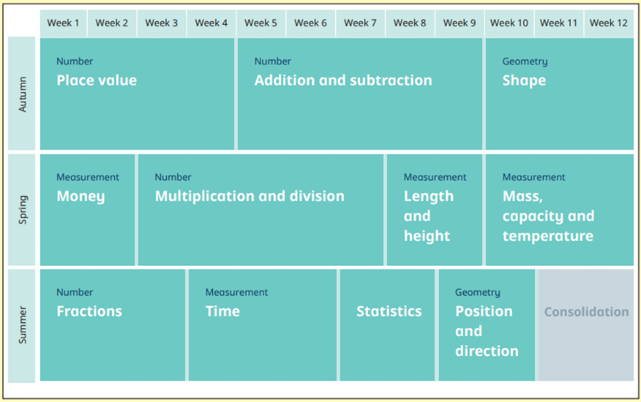
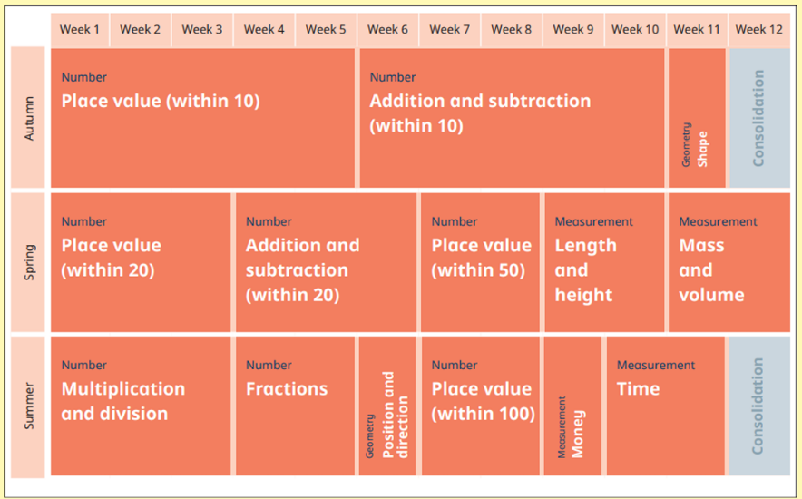
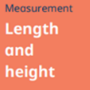
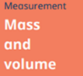
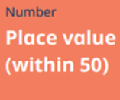
Year 2
Year 1

