Y6 Core Book List 2026-2027 (12 Books)

Non Fiction | 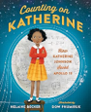 | Counting on Katherine by Helaine Becker  Counting on Katherine: How Katherine Johnson Saved Apollo 13 : Becker, Helaine, Phumiruk, Dow: Amazon.co.uk: Books
Non Fiction | 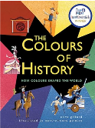 | The Colours of History: How Colours Shaped the World by Clive Gifford  The Colours of History: How Colours Shaped the World : Gifford, Clive, Peintre, Marc-Etienne: Amazon.co.uk: Books
Non Fiction |  | Tales of World War II: Amazing True Stories from the War that Shook the World by Hattie Hearn  Tales of World War II: Amazing True Stories from the War that Shook the World: 3 : Hearn, Hattie, Neon Squid, Esteves, Margarida: Amazon.co.uk: Books
Poetry | 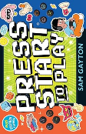 | Press Start to Play: A collection of interactive poems for young gamers  Press Start to Play: A collection of interactive poems for young gamers : Gayton, Sam: Amazon.co.uk: Books
Graphic Novel | 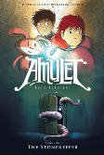 | The Stonekeeper (Amulet) by Kazu Kibuishi  The Stonekeeper (Amulet) : Kibuishi, Kazu: Amazon.co.uk: Books
Fiction | 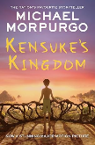 | Kensuke's Kingdom by Michael Morpurgo  Kensuke's Kingdom: The classic children’s novel of adventure and survival, now a major movie animation.: Amazon.co.uk: Morpurgo, Michael: 9780755503070: Books
Fiction | 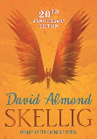 | Skellig by David Almond  Skellig: Winner of the Carnegie Medal : Almond, David: Amazon.co.uk: Books
Fiction | 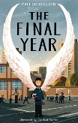 | The Final Year by Matt Goodfellow  The Final Year: CLiPPA Award-Winning Verse Novel for Ages 10-11 | Key Stage 2 : Matt Goodfellow, Joe Todd-Stanton: Amazon.co.uk: Books
Fiction | 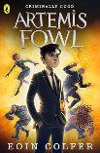 | Artemis Fowl by Eoin Colfer  Artemis Fowl: 1: Amazon.co.uk: Colfer, Eoin: 9780141339092: Books
Fiction | 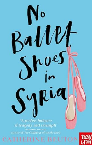 | No Ballet Shoes in Syria by Catherine Bruton  No Ballet Shoes in Syria : Catherine Bruton: Amazon.co.uk: Books
Fiction | 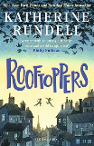 | Rooftoppers by Katherine Rundell  Rooftoppers: From the author of the internationally bestselling phenomenon Impossible Creatures: Amazon.co.uk: Rundell, Katherine: 9781526624802: Books
Fiction | 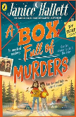 | A Box Full of Murders by Janice Hallett  A Box Full of Murders: The unmissable first children's mystery from the bestselling author of The Appeal: 1 : Hallett, Janice: Amazon.co.uk: Books

