Y2 Core Book List 2024-2025 (12 Books)
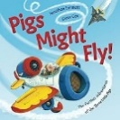
Fiction
- Pigs Might Fly by Jonathan Emmett
https://www.amazon.co.uk/Pigs-Might-Fly-Further-Adventures
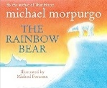
- The Rainbow Bear by Michael Morpurgo
https://www.amazon.co.uk/Rainbow-Bear-Michael-Morpurgo
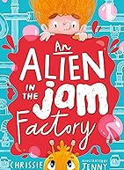
- An Alien in the Jam Factory by Chrissie Sains & Jenny Taylor
https://www.amazon.co.uk/Alien-Jam-Factory-Chrissie-Sains
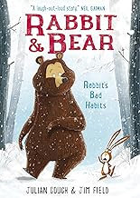
- Rabbit and Bear: Rabbit’s Bad Habits (Book 1) by Julian Gough
https://www.amazon.co.uk/Rabbits-Bad-Habits-Book-Rabbit
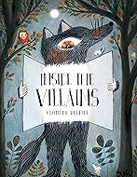
- Inside the Villains by Clotilde Perrin
https://www.amazon.co.uk/Inside-the-Villains
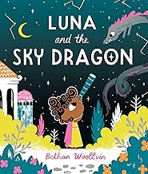
- Luna and the Sky Dragon by Bethan Woollvin
https://www.amazon.co.uk/Luna-Sky-Dragon-Bethan-Woollvin/

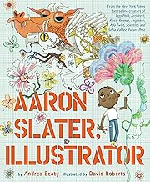
- Aaron Slater Illustrator by Andrea Beaty & David Roberts
https://www.amazon.co.uk/Aaron-Slater-Illustrator-Questioneers-Andrea

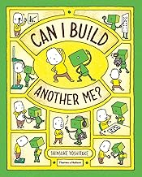
- Can I Build Another Me by Shinsuke Yoshitake
https://www.amazon.co.uk/Can-I-Build-Another-Me

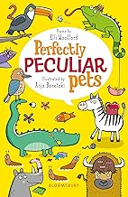
Poetry
- Perfectly Peculiar Pets by Elli Woollard & Anja Boretzki
https://www.amazon.co.uk/Perfectly-Peculiar-Pets-Elli-Woollard

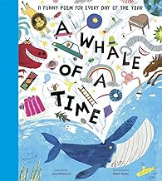
- A Whale of a Time: A Funny Poem for Everyday by Lou Peacock
https://www.amazon.co.uk/Whale-Time-Funny-Poetry-Collections /dp/1839942010/ref=sr_1_1?crid=290ZW26BOLWMP&dib=eyJ2IjoiMSJ9.PCGPK2

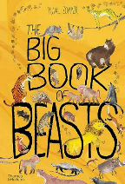
Non-Fiction
- The big book of Beasts by Yumal Zomer
https://www.amazon.co.uk/Big-Book-Beasts-

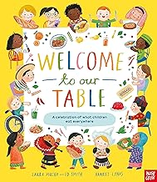
- Welcome to Our Table by Laura Mucha and Ed Smith
https://www.amazon.co.uk/Welcome-Our-Table-Celebration-Everywhere

