Church Vale SEND Report Autumn 2025

1. What kinds of special educational needs does the school/setting make provision for?
Church Vale is an inclusive school. We have an open door policy and work with parents and carers to ensure that that any barriers to learning are removed. Our ethos is learning without limits: "Reach for the Stars".
Ofsted November 2022
The special educational needs and/or disabilities coordinator (SENDCo) has a comprehensive understanding of pupils’ needs. Well-written plans ensure that pupils with special educational needs and/or disabilities get timely and appropriate support so that they achieve well. All pupils access a full and inclusive curriculum. Staff deliver the support and interventions that these pupils need well.

2. (For mainstream schools & maintained nurseries only) How does the school/setting know if pupils need extra help and what should I do if I think that my child may have special educational needs?

Most children attend our Foundation Unit as part-time pupils. In some cases they join us with their needs already assessed. We work closely with health and early years’ specialists to ensure a smooth transition into the setting. All children are assessed when they join our school so that we can build upon their prior learning. We use this information to provide starting points for the development of an appropriate curriculum for all our children.

A child has SEN if they have a learning difficulty or disability which calls for special educational provision to be made for them.

A child has a learning difficulty or disability if:
- Have significantly greater difficulty in learning than the majority of others the same age;
- or b) Have a disability which prevents or hinders them from making use of educational facilities provided for others of the same age in mainstream schools.

We recognise and cater for the four broad areas of need, which are:

● Communication and Interaction ● Cognition and Learning ● Social, emotional and mental health difficulties ● Sensory and/or physical needs

Where additional needs are identified, the class teacher will liaise with the school SENCo to discuss strategies and interventions. The SENCo or class teacher will meet with the parent/ carer and plan targets, signposting to additional support and external agencies where appropriate.

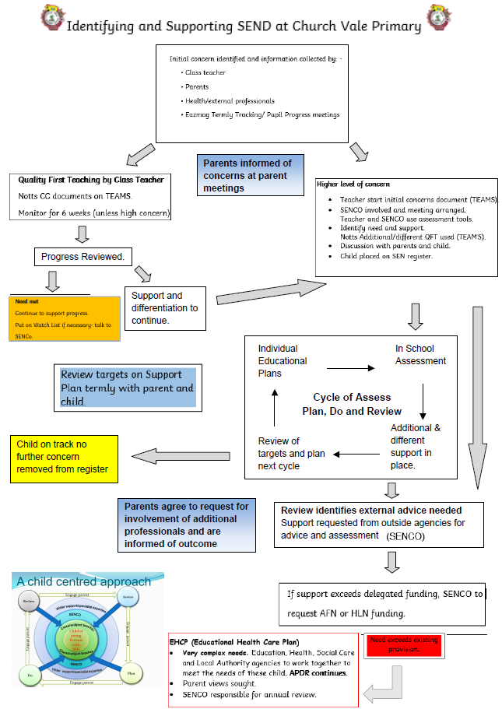

3.a) How does the school/setting evaluate the effectiveness of its provision for pupils with special educational needs?
Individual SEN assessments are made using bespoke tracking. SEN support plans have SMART targets which are monitored and regularly reviewed with all stake holders, to evaluate provision, monitor progress and attainment. BSquared Primary Progression Steps, Strengths and Difficulties Questionnaires, Motional Assessments are used to track progress across the areas of need. A range of intervention strategies are implemented. The impact of these is monitored and acted upon when necessary. Individual and small group support takes place. Parental satisfaction surveys, questionnaires and informal discussion forums are regularly held. Church Vale are taking part in the PINs project in 2024-2026 who will help to evaluate and strengthen provision.

3.b) How will both the school/setting and I know how my child/young person is doing and how will the school/setting help me to support their learning?

The progress of all pupils is monitored closely. Regular assessments, both formal and informal, take place to identify children below and above national expectations and to monitor progress. The SENCo and/or class teacher meet with parent/carers to review SEN support plans three times a year, and through annual EHC plan reviews where applicable. Parents are always welcomed into school to discuss their child's needs and progress.

3.c) What is the school's approach to teaching pupils with special educational needs?
We aim to provide every child with a sense of belonging and give them access to a broad and balanced education through making reasonable adjustments. We aim to create an environment that meets the needs of each child and to ensure that the special educational needs of children are identified, assessed and provided for. We liaise closely with outside agencies, where relevant, for advice and to gain expertise.
The school has a graduated approach to the management of Special Educational Needs.
Quality First Teaching

Class teachers will:
● take responsibility for the initial identification of the needs of all their children by monitoring the progress of each child in their class.
● plan and organise appropriately adapted work to meet each child’s needs
● monitor any pupils who are falling significantly outside of the range of expected academic
achievement in line with predicted performance indicators
● closely monitor any pupil who has been identified as possibly having SEN
● inform and engage with parents about their child’s progress and development
● share information about progress and development with the parent(s) at parents evenings or review.
- Engage in relevant CPD opportunities
● consult with the SENCO as needed for support and advice

SEN Support

Where pupils are identified as having a special educational need, this will be discussed with parents and the child’s name will be added to the school’s SEN register. The supportprovided consists of a four – part process:
● Assess
● Plan
● Do
● Review
(see flow chart)
3.d) How will the curriculum and learning be matched to my child/young person's needs?

Ongoing assessments are used to implement a range of intervention strategies. The impact of these is monitored and acted upon, when necessary. Adapted quality first teaching, individual and small group support takes place. BSquared progression steps may be used to track progress. In 2025-2026, the adaptation of the curriculum is on the school development plan and subject leaders are working in conjunction with school improvement consultants to adapt the curriculum for every learner.

3.e) How are decisions made about the type and amount of support my child/young person will receive?
The progress and needs of all pupils is monitored closely through observations and both formal and informal assessments take place to identify need and assess progress. This information, along with advice from outside agencies, is used to provide a graduated response. A provision map is in place which is regularly reviewed. Discussions between class teachers, teaching assistants and SENCo regularly take place both formally and informally. Pupil needs may be met through school funded provision, The Meden family funding, or county high level need funding where appropriate. For Foundation pupils, Inclusion Funding may be applied for.

3.f) How will my child/young person be included in activities outside the classroom, including school trips?

SEND pupils will be given access to the curriculum through the specialist SEND provision provided by the school as is necessary, as far as possible, in line with the wishes of their parents and the needs of the individual. Every effort will be made to educate pupils with SEND alongside their peers in a mainstream classroom setting. Where this is not possible, the SENCO will consult with the child’s parents for other flexible arrangements to be made. We operate our Hub Provision in the afternoons for those learners who need a lower stimulus, lower demand environment. Parents are signposted to access further support outside of school and in the wider community. Class teachers work with parents to plan the most appropriate provision for the child for school trips. All children have access to Forest Schools.

3.g) What support will there be for my child/young person's overall well-being?
A well-established Eco-Warrior Council ensure all pupils have a voice and their views are respected. School employs a school counsellor to work with children identified with SEMH needs and staff have undertaken Building Relational Schools training and Emotion Coaching training via EPS. All staff have accessed Mindfulness Training and pupils use Zones of Regulation and "Take 5" strategies to manage their emotions. We have an ELSA TA who works part time and delivers emotional literacy sessions, a yoga instructor who provides termly class sessions, neurodiversity and mindfulness groups and Forest School teachers to provide weekly Forest School provision. Where additional advice is required, school may, in consultation with parent/carers, refer pupils to Sherwood area partnership, Mental Health Support Team and Child and Adolescent Mental Health Team.

4. (For mainstream schools and maintained nurseries) Who is the school/setting's special educational needs co-ordinator (SENCO) and what are their contact details.
Harriet Gibbison
senco@churchvale.notts.sch.uk
01623 842250

5. a) What training have staff supporting special educational needs had and what is planned?
We recognise the need to train all our staff on SEN issues. The SENCO, with the senior leadership team, ensures that training opportunities are matched to school development priorities and those identified through the use of provision management. In addition the following training has taken place:
SEMH
- Coping with Risky Behaviour
- Draw and Talk
- Bereavement Counselling
- Mindfulness
- ACE (Adverse Childhood Experiences)
- ELSA
- Building Relational Schools
- Emotion Coaching
- Self Regulation in the Early Years
- Provision Mapper
- Dean Beadle- Further Autism Awareness
- St Giles Share Fest
- Hub Appreciative Enquiry with EPS
- Solihul training
C&L
- Dyscalculia
- Dyslexia in the Classroom
- Phonics
- Pre key stage standards
- Inclusive Classrooms Training
- Executive functioning skills
- Oracy training
- Visual Maths
P&S
- PE, Sport and Physical Activity
- Diabetes Awareness
- Manual Handling
C&I
- Supporting pupils with ASD
- ASD Champions
- Attention Autism
- PDA
- Interoception training
- C&I ECT An introduction to Autism and Neurodiversity
- Every Governor is a Governor of SEND
- Every Leader is a Leader of SEND
- Every Teacher is a Teacher of SEND

5.b) What specialist services and expertise are available or accessed by the setting/school?
- Speech and Language Therapy
- Chatter Speech and Language service
- Education Psychology Service
- SIS / SAP (Sherwood Area Partnership)
- Counselling/ Play Therapy
- Warsop Children's Centre
- Primary Mental Health Team
- ELSA

6. How will equipment and facilities to support pupils with special educational needs secured? How accessible is the school/setting?

Church Vale makes reasonable adjustments to remove barriers to learning and ensure that disabled staff, pupils, parents and visitors are not at any disadvantage. Liaison with outside agencies ensures that risk assessments are carried out and specialist equipment is in place.

Our school is on one level and we are periodically carrying out improvements to attempt to make Church Vale more accessible. We currently do not have a hygiene suite and are not fully wheelchair accessible.

7. What are the arrangements for consulting parents of pupils with special educational needs? How will be I involved in the education of my child/young person?

We operate an open door policy and encourage liaison and contact with parents and carers. We have “Welcome Meetings” for the parents/carers of new entrants in the Foundation Unit. Termly opportunities are provided to discuss academic progress as well as opportunities to attend more informal occasions such as concerts, fairs and displays of work. Individual concerns are discussed when they arise at meetings with class teachers and the SEN.

8. What are the arrangements for consulting young people with SEN and involving them in their education?
A well-established school council (made of EcoWarriors) ensures that all pupils have a voice and their views are respected. Ongoing improvements are planned for and monitored to ensure a safe, imaginative and happy learning environment. Pupils are involved in their own target setting and assessment. The SENCo holds pupil voice meetings with SEND children to ascertain their views.

9. What do I do if I have a concern or complaint about the SEN provision made by the school/setting?
If a parent or carer has any concerns or complaints regarding the care or welfare of their child, an appointment can be made by them to speak to the SENCO or headteacher, who will be able to advise on formal procedures for complaint.

10. How does the governing body involve other organisations and services (e.g. health, social care, local authority support services and voluntary organisations) in meeting the needs of pupils with special educational needs and supporting the families of such pupils?

We have a dedicated SEN link governor who meets with the SENCo throughout the year. The SENCO provides an SEN report which is shared with the governors.
The school continues to build strong working relationships and links with external support services in order to fully support our SEN pupils and aid school inclusion.
Sharing knowledge and information with our support services is key to the effective and successful SEN provision within our school. Any one of the support services may raise concerns about a pupil. This will then be brought to the attention of the SENCo who will then inform the child’s parents. The following services may be involved as and when is necessary:
Speech and Language Therapy
School and Families Specialist Services
Think Children
Peace of Mind/ Play Therapy
Warsop Children's Centre
Primary Mental Health Team
Sherwood Area Partnership

11. How does the school/setting seek to signpost organisations, services etc who can provide additional support to parents/carers/young people?
A well established understanding and knowledge of the local services is able to provide parents with relevant information as well as close links with other schools and settings in the Warsop area. A Parent Support worker is available when appropriate. We have a link to the Local Offer on our school website. Flyers and leaflets are displayed in the main entrances and on the parents’ notice boards to signpost parents to relevant information. These are also sent to parents electronically or through social media. Discussions with staff and SENCO are used to signpost parents. .

12. How will the school/setting prepare my child/young person to: i) Join the school/setting?

Most children attend our Foundation Unit as part-time pupils. In some cases they join us with their needs already assessed. We work closely with health and early years' specialists to ensure a smooth transition into the setting. All children are assessed when they join our school so that we can build upon their prior learning. We use this information to provide starting points for the development of an appropriate curriculum for all our children. Where appropriate a staggered start to school may be considered. A transition pack with preparatory photos is given to new starters.

ii) Transfer between phases of education (e.g. early years to primary, primary to secondary etc)?
Transition within school is designed to be seamless. Discussions at staff meetings ensure that all staff are aware of the needs of individual pupils. Records and information are passed on at teacher to teacher transition meetings and in the form of Pupil Passports. Liaison with Secondary Schools begins early in Year 6 or when appropriate for individual pupils. All parents have the opportunity to attend a meeting at local secondary and pupils attend for at least one day before the start of the Autumn term.
Advice sought from SAP and SIS around the transition of pupils with more complex needs.
The SENCo and/or class teacher meet with Secondary SEND teams for robust handover of information and need. If appropriate, extra visits are arranged for pupils as well as accessing the Sherwood Area Partnership transition package for identified pupils.

iii) Prepare for adulthood and independent living?
We aim to build confidence and develop high aspirations through our core values of community, possibility and self awareness.
We use Forest Schools to teach skills such as using tools.
We have additional swimming sessions at Warsop Health Hub for our SEN pupils.
Y5 pupils run Head Boy and Girl campaigns for whole school elections.
We teach explicit values to enable the children to grow up with strong British Values.
Hub provision focuses on key skills such as cooking.

13. Where can I access further information?
Parent Support worker, School Office, Warsop Children's Centre, School website
Local Offer Video https://youtu.be/W90gvdBgl_U

Updated September 2025

