
COMPUTING: PROGRAMMING- Selection in Physical Computing
KNOWLEDGE ORGANISER
Y5

Overview |  |  | Programming Blocks
  Selection in Physical Computing  - Programming is when we make and input a set of instructions for computers to follow.  -Lego WeDo 2.0 is an App which enables Lego models to be programmed in order to create movements using robotics.  -We use algorithms (a set of instructions to perform a task) which we can plan, model and test, in order to create accurate and imaginative robotic actions.  - Input- The data which is entered into a computer or device.  Output Device- The device which receives data from a computer or device.  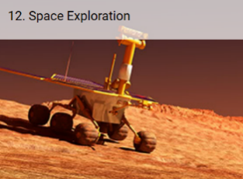   |  |  | -Output: Motor Blocks:  Motor This Way Block  Sets the motor to turn the axle in the direction shown.  Motor That Way Block  Sets the motor to turn the axle in the direction shown.  Motor Power Block  Sets the motor power to the desired speed and starts the motor.  Motor On For Block  Starts the motor for a chosen amount of time.  -Flow Blocks:  Start Block  Must be used at the beginning of a program string. Press on it to make the program start.  Wait for  Use this to tell the program to wait for something to happen.  Repeat Block  Use this block to repeat actions. Blocks placed inside will be looped.  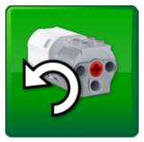  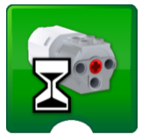  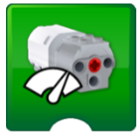  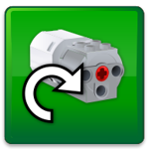            -Input Blocks:  Any Distance Change Number Input  Inputs the Motion Sensor mode “Any Distance Change” Inputs a numeric value to a block.  in a block.
Connection and Lego Kit
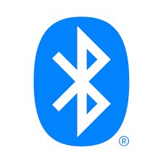
-Bluetooth Connection: Bluetooth enables a secure way to connect and exchange information between devices such as mobile phones, telephones, laptops, personal computers, printers, digital cameras, tablets, voice controlled devices and video game consoles. This connection is needed to exchange information from the App to the Lego model.

 |  |  | Sequencing and Algorithms | Trialing and Debugging
 |  |  | -A sequence is a pattern or process in which one thing follows another.  -We design algorithms (sets of instructions for performing a task) to help us program the sequence that we require to achieve our desired outcomes.  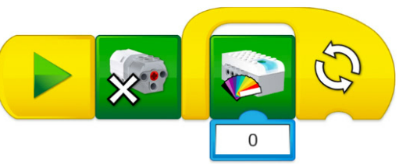  -Programming is the process of keying in the code recognized by the computer (using your algorithm). | -Programmers do not put their computer programs straight to work. They trial them first to find any errors:  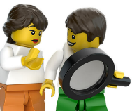  -Sequence errors: An instruction in the sequence is wrong or in the wrong place.  -Keying errors: Typing in the wrong code.  -Logical errors: Mistakes in plan/thinking.  -If your algorithm does not work correctly the first time, remember to debug it.
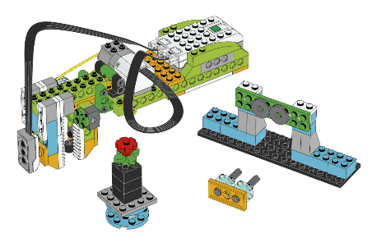  Grabbing Objects:  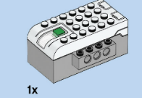  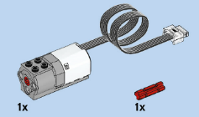  SmartHub  Motor | Space Exploration:  Select your own solution from these three:  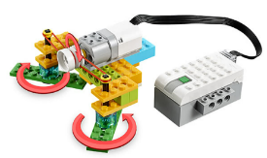  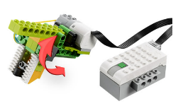  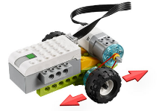  The motor connects to the SmartHub. The SmartHub connects the device to the computer or tablet using a Bluetooth signal.  Drive Grab Sweep
Important Vocabulary

Components Connect Infinite Loop Output Devices Motor Condition Input Action Selection

