
COMPUTING: COMPUTING SYSTEMS AND NETWORKS- Sharing Information
KNOWLEDGE ORGANISER
Y5

Overview |  |  |  |  | Transferring Information
  Systems  -You should also know that Information technology (I.T.) includes computers and things that work with computers.  -You should also know that computers have Input, Process and Output (IPO) components.  -Computer systems are built using a number of parts.  -Computer systems can communicate with other devices.  -There are many, many different kinds of computer systems all around the world, ranging from small-scale to large scale. |  |  |  |  | Protocols and Packets  -Protocols are an agreed way of doing something. When we communicate, we use an agreed set of protocols (greeting, speaking, listening, etc.).  -In computing, agreed protocols are the way that computers communicate with one another.  -The digital information they send is called a ‘packet.’  - Media, files and information can be shared on the internet either privately via email/cloud space  or publicly on  websites.   | IP Addresses  -Computers and their users are not always in the same place as one another.  With billions of computers around the world, computers need to send the information to the correct place.  -To do this, computers use special addresses called IP addresses. They may look like this:  From: 216. 58. 1. 214  To: 216. 64. 1. 20    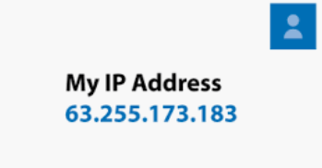
Systems
-Systems are a set of things working together as parts of a whole.
-Computer systems are made up of inputs (something that sends a message to the device), processes (the way the device acts on the message) and outputs (something that is sent out by the device). Below are some examples.
 |  |  |  |  | Working Together

-Collaborating is another word for working together on something, to reach a shared goal.
-The internet can be used to help people collaborate online, even when they are a long distance apart!
-‘Chat’ functions can be used keep each other updated with new information.
-Shared ‘cloud’ spaces and online drives can allow one or more person to have access to/ edit documents.
-When building upon someone else’s work, you need to be aware of copyright and intellectual property rules.

  Washing Machine:  Input: Dials and buttons.  Process: The computer inside follows a program.  Output: The clothes are washed and the display shows the remaining time. | 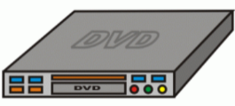  DVD Player:  Input: The disc is inserted and play is pressed on the remote.  Process: The system reads the information on the disc  Output: The screen displays the movie/ show. |  | Smart Locker:  Input: The customer scans in a barcode.  Process: The code is recognised by the system.  Output: The correct locker is opened.  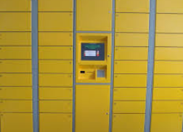

Important Vocabulary
System Connection Digital Input Process Output Protocol Address Chat Collaboration IP Address

