
COMPUTING: DATA AND INFORMATION- Data Logging
KNOWLEDGE ORGANISER
Y4

Overview |  |  | Data Recording
Data Logging  -Data is raw numbers and figures. Information is what we can understand from analysing data.  -There are lots of different ways that we can collect, log and interpret data, including by using data loggers.  -Data loggers and logging software can be used to automatically capture data. We can then draw conclusions in answer to our research questions.  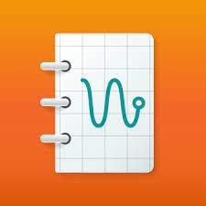  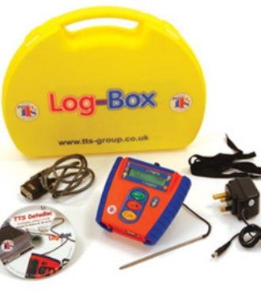  Arduino Science Journal App |  |  | 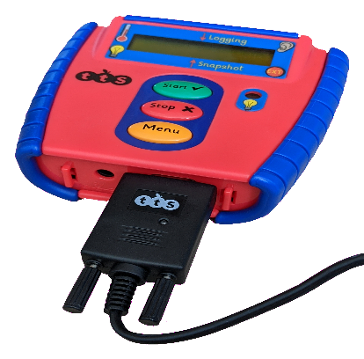  -One way for us to record data is by writing it down. Some data loggers can also record data themselves, which we can download later. Computers can also help us to record data, e.g. by connecting our data loggers to computers and opening data logging software.  -An advantage of this is that computers can record data automatically, meaning that someone does not need to sit waiting for a long period of time. Data loggers can be set to measure at different intervals (points in time).  -Data logger software can also be used to show different charts and graphs. This can save the user a lot of time!  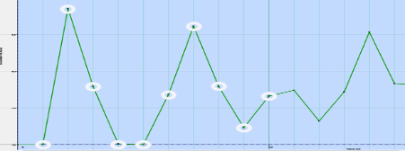  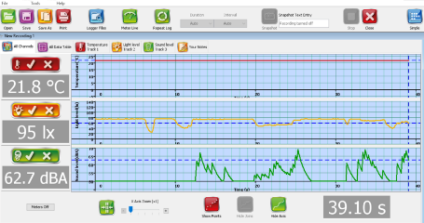
Data Collection
Asking Questions: Data gathered over time can be used to answer important questions.
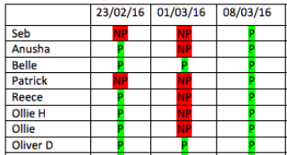
For example, the class register can be used to answer questions about children’s attendance. Before collecting data, we need to carefully consider which questions we are trying to answer.
 |  |  | Analysing Data | Answering Questions
 |  |  | -When scientists collect data, they usually store it so that it can be analysed at any time. The data can also be shared so that other scientists can use it.  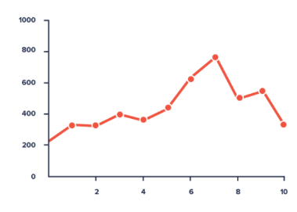  -Tables and graphs can be used to present the data in a useful way for reading and understanding it. It is important to be able to see trends as clearly as possible. | -Remember that data should be collected for a reason: to answer questions.  -It is very important to ensure that the testing that you do is fair and reliable, otherwise the data that you get back may not give you the accurate answers that you need.  -It is important to interpret your data carefully. You can then write a report detailing what your conclusions are.
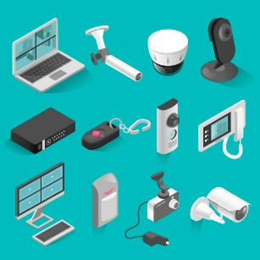  -Sensors: Our senses (sight, hearing, smell, taste, touch) detect things in our environment. Computers have input device sensors which help them to sense things.  Some examples are:  -Microphones (sound)  -Camera (light)  -Touchscreen (touch) | 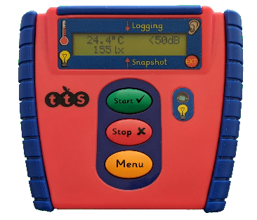  - Data Loggers: Data loggers have sensors built into them. They can be used to detect and record data.  Data loggers often contain:  -A heat sensor (to record the temperature)  -A light sensor (to record brightness)  -A sound sensor (to record the noise).
Important Vocabulary

Input device Sensor Data logger Logging Data point Interval Analyse Data set Import Export Logged Collection Review Conclusion

