
COMPUTING SYSTEMS AND NETWORKS- The Internet
KNOWLEDGE ORGANISER
Y4

Overview |  |  |  |  | The World Wide Web
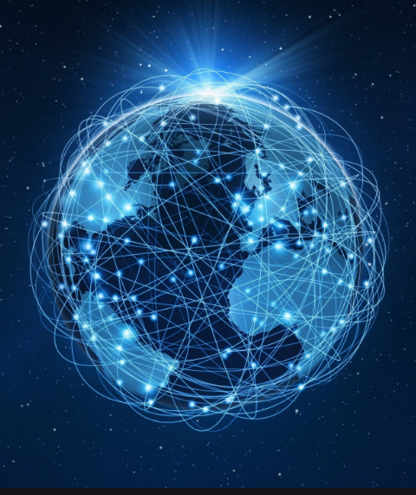  The Internet  -You should also know that Information technology (I.T.) includes computers and things that work with computers.  -You should also know that information and data can be shared by devices across networks.  -The internet is a network of networks that is used around the world.  -The World Wide Web is a system on the internet that has websites and webpages.  -Some content is protected on the internet. It is important to know that not all information on the internet is accurate, honest, or legal. Websites and their content are created by people. |  |  |  |  | Website and Webpages  -Websites are a set of webpages.  -Webpages may contain different features, e.g. a title, links to other pages, images, videos, and text.  -Websites and webpages can be found using web addresses (domains), normally split into three parts:  1. www (world wide web).  2. Name of the organisation/ topic.  3. Type of organisation/ location.  - A web address may also be called a URL (Universe Resource Locator). This is the text you type into your internet browser when you want to visit a website.  The World Wide Web  -The World Wide Web is the part of the internet where we can visit web pages and websites.  -Information can be shared in the form of things we can see or hear (e.g. things we can read, music, sounds, or videos, etc.).  -When we use the world wide web, routers help us to journey to different networks in different parts of the world.  -We can use traceroute tools to track the journey between routers.  -Web browsers, e.g. Google Chrome and Internet Explorer, let us look at different pages on the internet. | 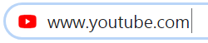
Networks and The Internet
-Networks connect different devices to one another, allowing for information sharing.
-Networks can also connect to other networks in different places, using a router.
-The internet is a network of networks that are all connected together.

 |  |  |  |  | Ownership and Reliability
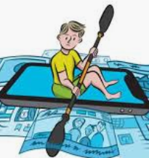
-The content on the internet may belong to different people or companies, for example the person who wrote it or the company who published it.
-The content may be copyrighted, meaning that others cannot copy or use it without permission.
-Not all of the information that we see or hear on the internet is reliable. Some of it may be inaccurate due to people lying or misunderstanding things.
-Inaccurate information can quickly spread. This has become known as ‘fake news.’ We should check multiple sources that we can trust to verify information.

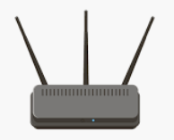  Router: A router is something that finds a route between networks, connecting them. | 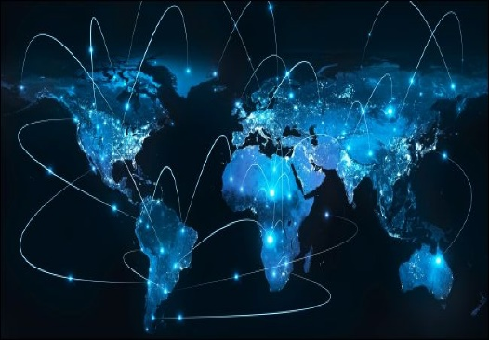  The Internet: The internet is a network of networks, that is used around the world to share information and communicate. |  | 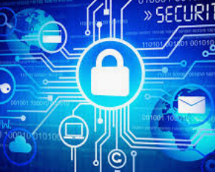  Protection: Networks have security features that mean they can block or allow messages and requests. This means that information and data can be kept safe.

Important Vocabulary
Network Router Network Security Network switch Server Wireless access point (WAP) Browser World Wide Web Content Links Files Download Sharing Ownership Permission Information

