
COMPUTING: CREATING MEDIA- Stop-Frame Animation
KNOWLEDGE ORGANISER
Y3

Overview |  |  | Creating a Basic Animation
  Animation  -Animation is a technique used to make objects and drawings/images appear as if they are moving.  -Stop-frame animation is a technique in which many photographs are taken of objects, with small movements in between.  -When the images are quickly shown together, the objects appear to move! (They are animated).  -There are many stop-frame animation apps and programs, for example iMotion, Stop Motion Studio and Clayframes.  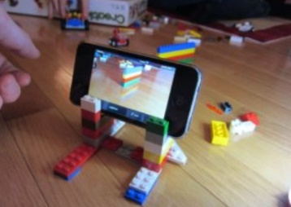    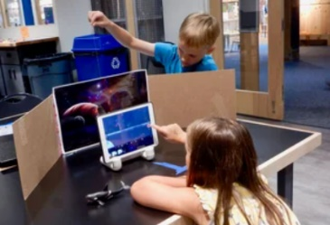 |  |  | 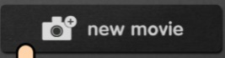  iMotion is one of many apps that you can use to create animation. You can create a new animation by selecting the ‘new movie’ option.
 |  |  | 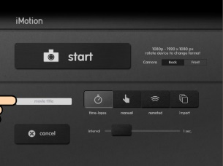  Setting Up  -Select ‘manual.’ Type in the movie title.  -Tap ‘Start’. Turn on ‘onion skinning’  -Make sure that your object/ drawing is in the frame (can be seen by the camera).  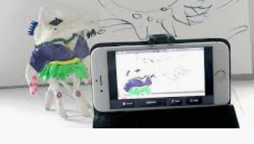 | Creating the Animation  -Take a picture of your object/ drawing (press ‘capture’).  -Change the object/drawing very slightly. If drawing, keep a feint line of the original drawing to show you where to go next (onion skinning). Capture again.  -Repeat the process lots of times.
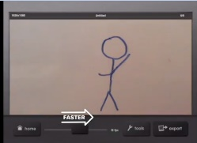
Playback and Saving: When you are finished, press ‘stop’ and then ‘stop’ again. Your animation will begin playing. You can change the speed (frames per second). Press ‘export’ to save your animation.

Introduction to Animation
Animation is a technique used to make objects and drawings appear to move.
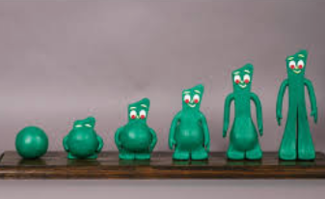  Animations have been around for many years – even before computers! Stop-frame animations work in the following way:  -A number of pictures are drawn or taken of an object or picture.  -In each drawing or picture, the object has been moved slightly. Each picture is called a frame.  -When the frames are shown in a sequence, an illusion is created where it looks as though the object is moving!  Lots of movies and TV programmes are animated. These include cartoons, and films like Wallace and Grommit and Chicken Run.  -In recent years, lots of stop-frame apps and programs have been released, which can be used to make homemade animations!  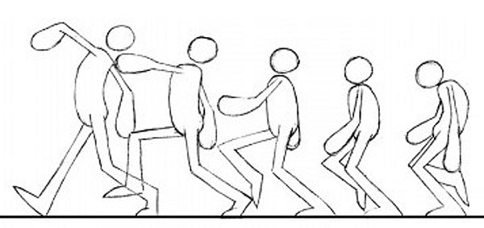  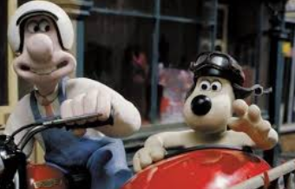 |  |  | More Complex Animations  Storyboards can be used to plan animations. They help you to plan your different frames.
 |  |  | 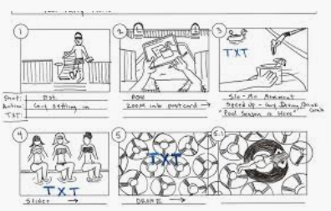 | 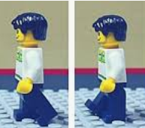  -Consistency is important. In each frame, we need to think about which things stay the same (e.g. background), and which things change.
 |  |  |     -Add music by tapping ‘audio.’ You can add in soundtracks, your own music, or sound effects. Tap + to select the track that you want. Carefully choose when the audio starts/ stops. | 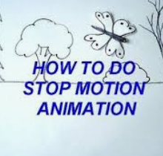  -You can also add text into your animation. Tap on the frame that you want to enter text into. Tap T for text. You can choose different fonts, and select where you want the text to appear.
Important Vocabulary

Animation Flip book Stop-frame animation Frame Sequence Image Photograph Setting Character Events Onion skinning Media Import Transition

