
COMPUTING SYSTEMS AND NETWORKS- Connecting Computers
KNOWLEDGE ORGANISER
Y3

Overview |  |  |  |  | Networks and Network Devices
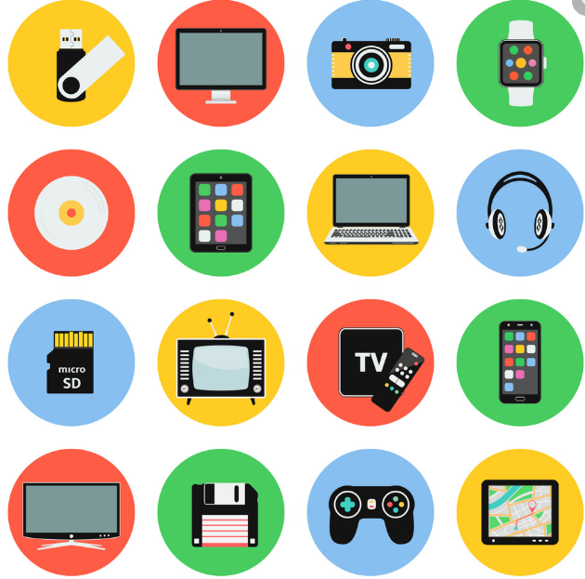  Digital Devices  -You should already know that Technology is something that has been made by people to help us.  -You should also know that Information technology (I.T.) includes computers and things that work with computers.  - Digital devices are things made for a particular purpose, that use processing.  Digital devices have an input, process, and output (IPO).  -Information and data can be shared across networks. Many devices are used to create networks. |  |  |  |  | Network Devices  -Network switch: a device that helps different devices on a network to be connected with each other.  -Server: a computer that manages the network and stores files  Wireless access point (WAP): a device, connected to a wired network, that sends and receives wireless signals to and from devices.  Connections and Networks  -In Computing, a connection describes a link between the computer and something else.  -For example, a computer may be connected to the internet through wires, a mobile data system, or WiFi.  -A computer network is a set of connections that joins computers together.  -The computers in the network can send and receive information to one another.  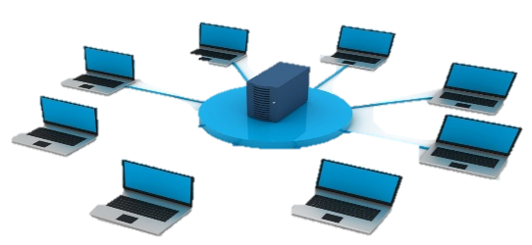 | 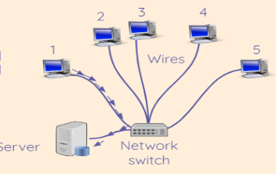
Digital Devices – Input, Process Output (IPO)
-A device is something that has been made for a particular purpose (it has a special use). Interactive Whiteboards and CleverTouch screens are a good tool for teaching and learning, iPads and other tablets are a good tool for researching, creating, storing and taking images. There are many devices suitable for different purposes.
-Digital devices use processing (have a process) There is more than just an on-off function.
Digital devices have an input, process, output (IPO)
 |  |  |  |  | Why Networks Are Useful
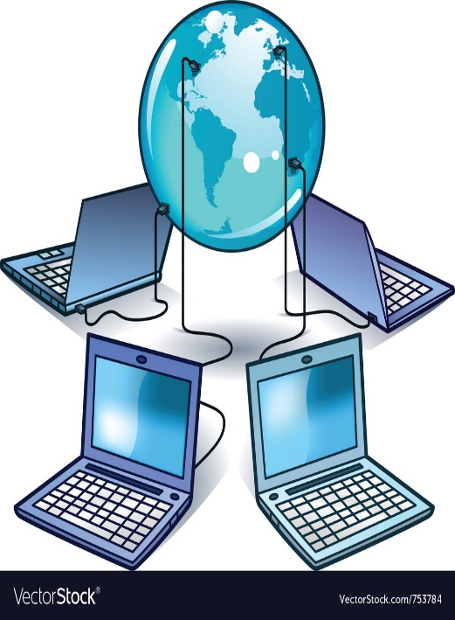
-Computer networks allow us to send and receive information between computers that are in different places.
-Networks can help us to communicate quickly and easily.
-Networks can also join computers to shared devices, like scanners and printers.
-The internet is a global network of computers. Imagine how different life would be without the internet!
-If information is shared on a network, it helps to reduce the risk of data being lost, e.g. if one computer breaks.

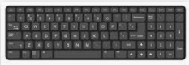  Input Devices: Keyboard, joystick, mouse, web cam, microphone, touch screen, track ball, digital camera.  Input: Something that sends a message to the device. E.g. You press a button on the keyboard. | 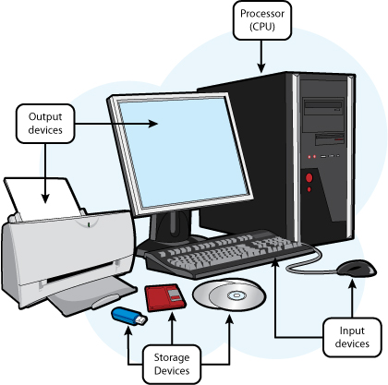  Process: The device acts on the message. E.g. The computer follows a program that tells it what to do when the keyboard is pressed. |  |   Output Devices: Screen/monitor, printer, headphones, projector, speaker, smartboard.  Output: Something that is sent out by the device. E.g. The letter that you have typed on the screen.

Important Vocabulary
Digital Device Input Output Process Program Connection Network

