
COMPUTING: PROGRAMMING- Robot Algorithms
KNOWLEDGE ORGANISER
Y2

Overview |  |  | Algorithms and Instructions
  Robot Algorithms  - Programming is when we make a set of instructions for computers to follow.  -Robots are one type of machine that can follow programs - they follow what we instruct them to do.  -We use algorithms (a set of instructions to perform a task) to help robots to do things that we want them to. Debugging can help to correct algorithms and programs. |  |  | -Algorithms: Algorithms are precise set of instructions, that a computer can turn into a code. A floor robot has a computer inside of it.  -Programs: When we press the buttons of our floor robot, we are creating a program for it to follow. The program is how the algorithm is run as code on the robot.  -Instructions: It is important that our instructions to the floor robot are clear. If our sequence of instructions is in the wrong order, has anything missing, or has anything additional, the floor robot will end up in a different place! Plan the route to avoid obstacles and get to the right place.      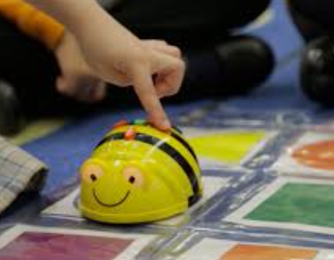
Using a Floor Robot

-Robots: Robots are machines that we can program to do human jobs.


-Robots help us to do things, for example to help us clean, mow and learn!

-Robots in factories make things, and in hospitals they help make us better.
 |  |  | Designing Algorithms | Chunking and Debugging
 |  |  | 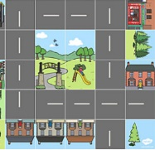  -We can buy or create mats for floor robots. We then need to design our algorithms so that the robot follows the given route.  -We should carefully consider the start point & end point that we want the robot to reach.    -Use symbols (e.g. arrows, crosses) to indicate the commands that will be inputted as a program. | -Chunking: With larger programs, we can break the task into chunks and create algorithms for each chunk.  -Debugging: Debugging is finding and fixing errors in our algorithms and programs. These errors can include:  -Sequence errors: An instruction in the sequence is wrong or in the wrong place.  -Keying errors: Typing in the wrong code.  -Logical errors: Mistakes in plan/thinking.
  -Turning on a Bee-bot: Before we use a Bee-bot, we need to make sure it is charged.    To turn it on, using the switch underneath. You can tell that the Bee-bot is on because its eyes light up. Remember to switch it back off again after you have finished using it. | 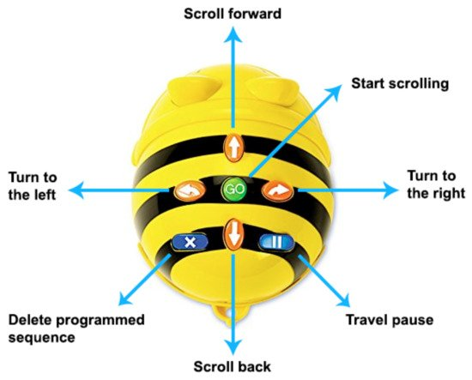  -Buttons: Bee-bots have buttons on the top. They each make the Beebot do something different (see picture).  -The arrows move the Bee-bot in different directions. The GO button makes the Bee-bot start its program. The X button makes the Bee-bot forget the last set of instructions.
Important Vocabulary

Instruction Sequence Clear Order Commands Prediction Design Route Debugging

