
COMPUTING: CREATING MEDIA- Making Music
KNOWLEDGE ORGANISER
Y2

Overview |  |  | Music Vocabulary
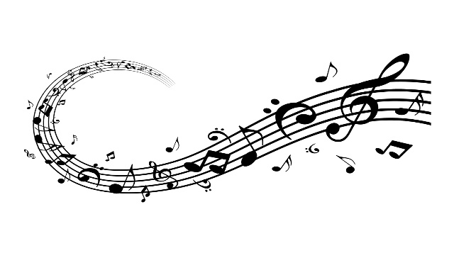  Making Music  -We can use digital devices to help us to create, edit and listen to music.  -Music can make us think and feel different things.  - Rhythm, pitch and tempo can be used to change the sound and emotion of music.  -We can also use lots of different apps and programs to edit and improve photos, for example Chrome Music Lab, Magic, and Music Maker.  -We should understand the advantages of creating both digital and non-digital music.    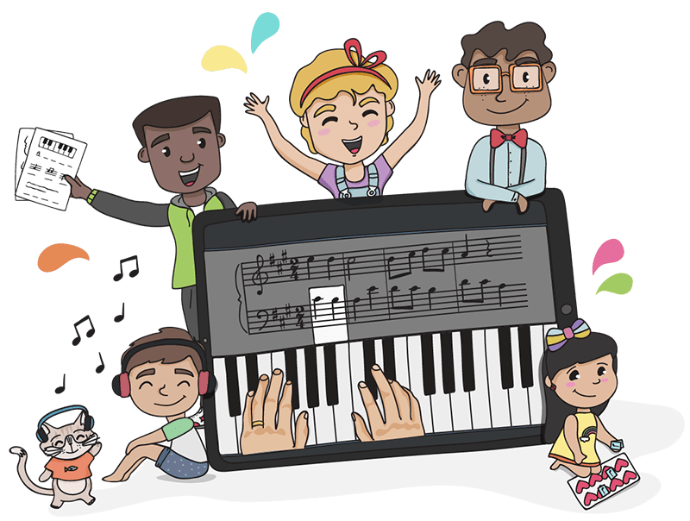 |  |  | There are lots of different things to consider when we are making and listening to music. Some of the most important words that you should know are below.
 |  |  | 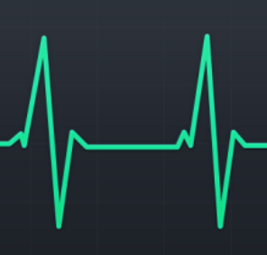  Pulse is the steady beat, like a ticking clock or a heartbeat. Music has a pulse. Sometimes, we can clap or move in time to the pulse of music. |   Rhythm is the pattern of long and short sounds in music. In lots of music, a rhythm is repeated throughout the song.
 |  |  | 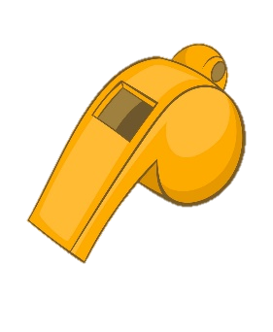  The pitch is how high or low a sound is. An example of a high-pitched sound is a whistle, a low-pitched sound is a drum. | 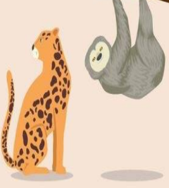  The tempo is how fast or slow the music is. Fast-tempo music can sound energetic or frightening. Slow-pitched music can sound sad.
Describing Music |  |  |   Volume is how loud or quiet something is. When making music, we can use loud and quiet sounds to show different ideas and emotions.
Music is a type of art that can be heard. It can make us feel different emotions.

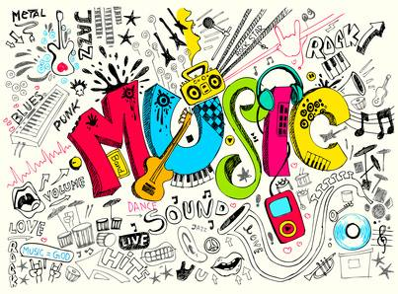  Some words to describe music:  Loud Soft Gentle Fast Slow  Catchy Boring Interesting Noisy  Smooth Modern Old-fashioned Scary |  |  | Using Song Maker
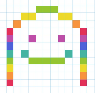
-On Chrome Music Lab, click on the multi-coloured smiley face for Song Maker.

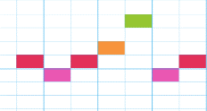
-By clicking on the different squares, you can make different musical notes. The higher up you click, the higher the pitch!
-Clicking on the shapes below the notes allows you to add in percussion, e.g. drums and symbols.
-You can change the instruments that make the sounds, by clicking on the different options in the bottom left.
-By moving the dot along this bar (at the bottom of the page) you can change the tempo, making it faster or slower.
-This symbol lets you listen to the music that you have made!

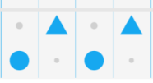



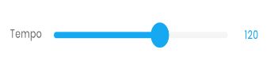



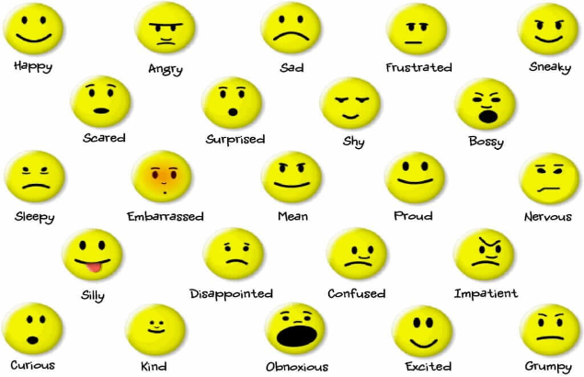
Music can make us feel different emotions.
Some of these emotions may include:
Happy Sad Excited Depressed
Bored Worried Angry Nervous
Scared Surprised Motivated Tired

Important Vocabulary

Music Quiet Loud Feelings Emotions Pattern Rhythm Pulse/Beat Pitch Tempo Notes Instrument Create Open Edit

