
COMPUTING: PROGRAMMING- Introduction to Animation
KNOWLEDGE ORGANISER
Y1

Overview |  |  | Sequencing
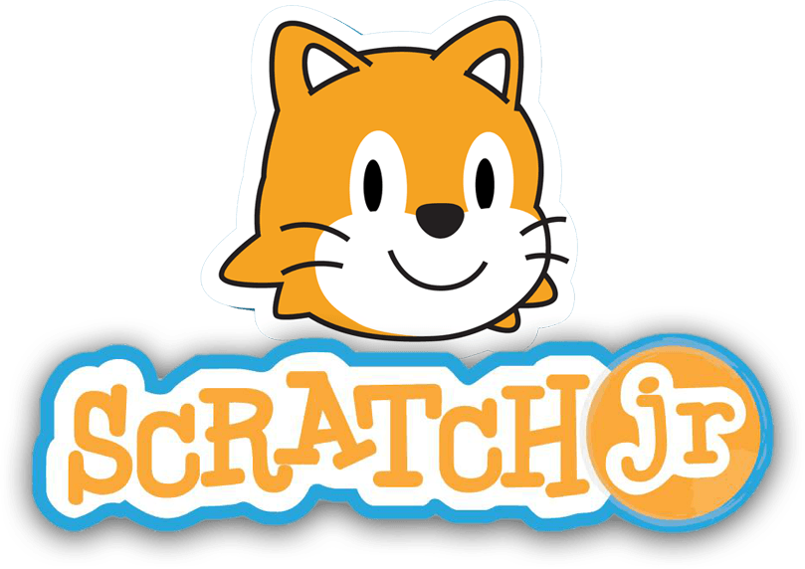  Animations in Scratch Jr.  - Programming is when we make a set of instructions for computers to follow.  -Scratch Jr. is a program that we can use in order to code our own stories and animations. It involves sprites (characters on the screen).  -We use algorithms (a set of instructions to perform a task) to program the sprite to do different things.  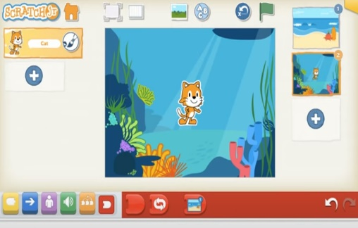 |  |  | -Sequences: -A sequence is a pattern or process in which one thing follows another. In Scratch Jr. we can stack blocks together side by side in order to create programs made up of sequences.  -Deleting Blocks: Blocks can be removed from programs by dragging them from the programming area back into the blocks palette.  -Repeating Blocks: For something to happen more than once, we can change the number underneath the block.  -Running the Code: Run your animation by tapping the full screen icon, and then the green flag.  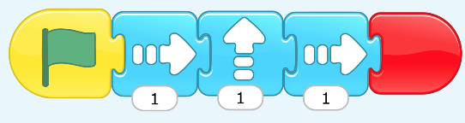  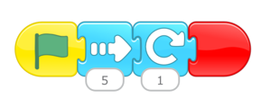      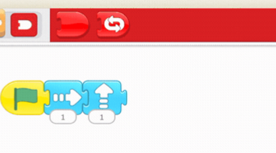
The Basics of Scratch Jr.
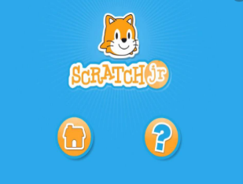
-What is Scratch Jr? Scratch is a website/ app that lets us code our own stories, games and animations.
-Sprites: Scratch Jr. uses characters called sprites. The main sprite is a cat called Scratch.
-Home: Clicking on the house takes you ‘home’ to your project screen.
 |  |  | Algorithms and Programming | Debugging
 |  |  | 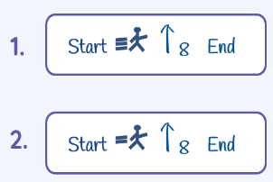  -An algorithm is a set of instructions for performing a task. Designing an algorithm can help us to make the sprite do the things that we want it to do.  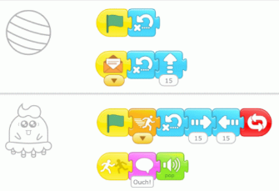  -Programming is when we move the blocks into the position (based on our algorithm design). Our programming codes the sprite to perform the actions. | 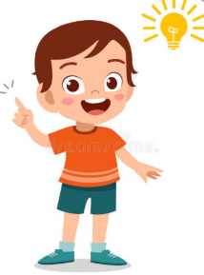  -Sometimes, things don’t work exactly how we want them to the first time. This may be a problem with our algorithm, or we could have made a mistake in our programming.    -If the animation does not work correctly the first time, remember to debug it. This means finding and fixing the problems.
Getting Started    -The + starts a new project.  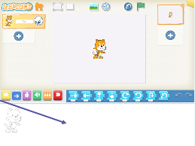    -These are programming blocks. We drag them into the programming area (right). Clicking the block in the area makes the sprite perform on the stage. | - Moving Blocks: These make the Sprite move in different ways.    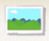  -Background: Backgrounds are added by clicking this icon (right).    -Start Blocks: Start blocks are yellow. These are used to start/ run programs.    -End Blocks: End blocks are red. These show what happens at the end of your program.
Important Vocabulary

Command Sprite Compare Programming area Block Joining Start block Run Background Delete Reset Predict Effect Change Value Instructions Design

