Intent
The intent of Church Vale’s Science curriculum is to enable our pupils to be able to ‘think like scientists’. Pupils will develop their scientific knowledge and understanding through the disciplines of biology, chemistry and physics. Pupils will develop an understanding of the nature, processes and methods of science through different types of science enquiries that help them to answer specific questions about the world around them. Through science, children develop a sense of excitement and curiosity. Church Vale’s Science curriculum equips pupils with the scientific knowledge required to understand the uses and implications of science, today and for the future.
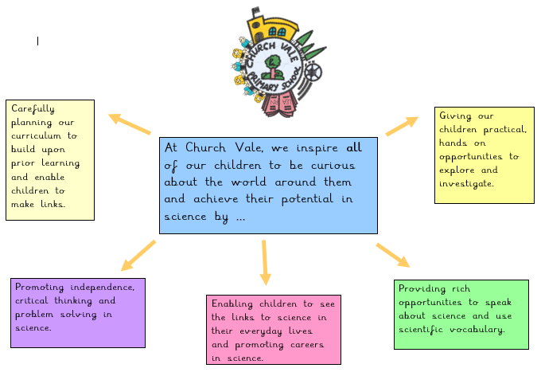

Key Concepts
Lessons will focus on the key concepts of being a scientist, within the breadth of the KS1 and KS2 substantive knowledge. The broad key skills for Science are:
- Asking questions
- Planning investigations
- Making observations
- Taking measurements
- Gathering, recording and classifying data
- Presenting findings
- Answering questions and making conclusions
- Evaluating

We recognise that objectives will focus on attaining or developing a skill, within the context of substantive scientific knowledge e.g. to classify animals according to their diet.
Interwoven throughout the Science curriculum, our 3 core Church Vale values of possibilities, community, and self-awareness will be explicitly explored alongside and within our breadth of study. Each topic will have a focus ‘possibility’ – a STEM career linked to the scientific field the children are working on. They will explore what day to day life looks like in this role alongside the attributes suited to this role. They will be encouraged to reflect on the question ‘Could you be a …?’
Implementation
Specific areas of substantive knowledge are taught longitudinally over a school year, as shown in the table below. This enables our children to observe over time and make connections in the world of science. We plan for children to acquire both substantive and disciplinary knowledge. Working scientifically should be embedded within the content of biology, chemistry and physics, focusing on the key features of scientific enquiry, so that pupils can learn to use a variety of approaches to answer relevant scientific questions.
‘Flashback Five’ happens at the beginning of every lesson to enable learners to revisit previously learned material (this may be from the previous lesson, previous unit or previous year).
Learning questions for each lesson in KS1 and KS2 have been developed as a vehicle for the development of both substantive and disciplinary knowledge as well as enabling children to consider the application of scientific knowledge in their own lives.
Key scientific vocabulary is mapped on children’s knowledge organisers. Children work in groups, pairs and individually. Opportunities to talk about their observations, learning and use scientific vocabulary are abundant.
Children may record in Science books and through Seesaw.
Science is taught weekly across KS1 and KS2. In EYFS children access ‘The World’ though out their sessions via continuous provision, weekly carpet times, small focus groups and Forest School. Learning in EYFS is recorded through Tapestry observations and the class floor books.

 | Autumn 1 | Autumn 2 | Spring 1 | Spring 2 | Summer 1 |  | Summer 2 | Longitudinal | Working Scientifically
Y1 | Animals including humans |  | Everyday materials |  | Plants |  |  | Seasonal changes | Working Scientifically
Y2 | Animals including humans |  | Uses of everyday materials |  | Living things and their habitats |  |  | Plants | Working Scientifically
Y3 | Rocks |  | Animals including humans | Forces and magnets | Light |  |  | Plants | Working Scientifically
Y4 | Living things and their habitats |  | Electricity | Sound | Animals including humans | States of matter |  |  | Working Scientifically
Y5 | Earth and space |  | Forces | Living things and their habitats | Properties and changes of materials |  | Animals including humans |  | Working Scientifically
Y6 | Electricity | Light | Animals including humans | Living things and their habitats | Evolution and inheritance |  |  |  | Working Scientifically

Pupils will gain ‘cultural capital’ and build on their key concepts as they are applied to the knowledge they acquire.
EYFS
Foundation 1 and Foundation 2 children develop their Understanding the World knowledge and skills through continuous provision areas including the ‘investigation station’ and our outdoor provision as well as carpet times, high quality texts and small group guided work. Once a week they have an ‘Understanding the World’ carpet time where new experiences and vocabulary are introduced. Activities are carefully planned to deepen children’s knowledge, understanding and skills as well as providing the opportunity for them to explore and ask questions. Key vocabulary is identified and modelled by staff.
Opportunities in provision are also carefully planned to develop the Characteristics of Effective Learning – these are the key to building the foundations of disciplinary knowledge and skills for our early learners.
Our Forest School programme is carefully designed to give our Foundation children the opportunity to develop the Characteristics of Effective Learning as well as observe changes in the natural world throughout the seasons.
Impact
Learners make links between aspects of science studied across the whole of Church Vale. Learners are equipped with skills to develop, test and answer their own scientific questions about the world around them. Ultimately, learners will possess the scientific knowledge required to understand the uses and implications of science, today and for the future. Year 6 learners are well equipped to continue their learning in KS3.

Natasha Rawcliffe

July 2025

